|  |  |
| --- | --- |
| Module: | Academic Advisement / Curricular Affairs |
| Business Process Name: | UAccess Curriculum Updates |
| Created By: | Brad Hensley |
| Creation Date: | April 28, 2015 |
| Revised: | August 15, 2019 |
| Last Revised By: | Abbie Sorg and Martin Marquez |

Contents

The Curriculum Update Process 2

Curriculum Update Contact Information 3

Security Roles 4

Useful Information for Submitting Curriculum Updates 5

Submitting Curriculum Updates in UAccess 6

Edit Line 8

Add New Line 11

Edit Requirement 13

Edit Requirement Group 15

Discarding or Editing an Update 16

Curriculum Update Extras Tab 18

Submitting Updates After the Deadline 19

Reviewing Curriculum Updates in UAccess 20

Group/Req/Line Edit Tab 21

New Lines Tab 24

Plan Extras Tab 25

College Tab 26

Viewing Archived Curriculum Updates 27

Viewing Curriculum Updates Statistics 29

Viewing Academic Requirements 30

Line Item Parameters Tab 31

Hidden Line 32

Line Item Tab 33

Limit Line 34

Viewing Course Lists 35

Line Item Detail Tab 35

Define Course Lists 36

Course List Detail Tab 36

The Curriculum Update Process

Curriculum updates go through the following annual process:

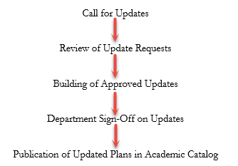

Call for Updates:

A call for curricular updates will be made through Curricular Affairs (typically in August). Those responsible for updating curriculum will need to log in to the Curriculum Update module and submit updates by the stated deadline. Submissions made after the deadline require a justification statement for consideration and will go through a more thorough review process. See bottom of page 5 if no updates are required.

Reviewing Update Requests:

Curricular Affairs reviews all submissions. Approved updates will move forward to the Student Administration AA/DT team for implementation. Curricular Affairs will follow-up with the department to clarify requests, discuss issues, and work toward resolution as needed.

Implementing Approved Updates:

Once an update request is approved by Curricular Affairs, the AA/DT team can begin implementing the changes on the Advisement Report. Curricular Affairs and/or AA/DT team may contact the department with questions or feedback regarding the updates.

Department Sign-Off on Updates:

The updated Advisement Report will be sent to the department. The department should review the updated Advisement Report and inform Curricular Affairs and AA/DT of any issues or additional changes within one week. **If no feedback is received within one week, the updates will be considered “accepted” by the department.**

Publication of Updated Plans in Academic Catalog:

In April, AA/DT will publish the updated plans in the forthcoming year’s Academic Catalog. Any outstanding updates will be updated in the Academic Catalog once all issues have been resolved and implemented.

College Approval of Curriculum Updates:

Deans, Associate Deans, and/or other stipulated Dean’s Office personnel may review the updates submitted by their college. Individuals wishing to be part of this process need to contact Curricular Affairs for appropriateness, security provisioning, and training. The college-level approval process is not part of the official workflow, so review and building of the plans by Curricular Affairs and AA/DT will continue even if no feedback is provided.

Curriculum Update Contact Information

|  |  |  |
| --- | --- | --- |
| **College** | **Curricular Affairs Contact** | **AA Business Analyst Contact** |
| College of Agriculture and Life Sciences | Stephanie Carlson | Heather Jepsen |
| College of Architecture Planning, & Landscape Architecture | Stephanie Carlson | Heather Jepsen |
| College of Education | Stephanie Carlson | Heather Jepsen |
| College of Engineering | Liz Sandoval | Heather Jepsen |
| College of Fine Arts | Liz Sandoval | Heather Jepsen |
| College of Humanities | Stephanie Carlson | Kristin Eaton |
| College of Letters, Arts, and Science | Stephanie Carlson | Heather Jepsen |
| College of Medicine | Stephanie Carlson | Kristin Eaton |
| College of Nursing | Stephanie Carlson | Kristin Eaton |
| College of Pharmacy | Liz Sandoval | Kristin Eaton |
| College of Science | Liz Sandoval | Kristin Eaton |
| College of Social and Behavioral Sciences | Stephanie Carlson | Kristin Eaton |
| Eller College of Management | Liz Sandoval | Kristin Eaton |
| Honors College | Stephanie Carlson | Kristin Eaton |
| Mel and Enid Zuckerman College of Public Health | Liz Sandoval | Kristin Eaton |
| UA South | Liz Sandoval | Heather Jepsen |
| Undergraduate Certificates | College Curricular Affairs Contact | Heather Jepsen |

**Contact Information:**

* Stephanie Carlson [scarlson@email.arizona.edu](mailto:scarlson@email.arizona.edu)
* Kristin Eaton [sadue@email.arizona.edu](mailto:sadue@email.arizona.edu)
* Heather Jepsen [jepsenh@email.arizona.edu](mailto:jepsenh@email.arizona.edu)
* Liz Sandoval [esandmar@email.arizona.edu](mailto:esandmar@email.arizona.edu)

There are various reasons that you may want to reach out to our offices and it may not always be clear who to go to for your questions. Here are some examples of reasons you may want to connect and who can assist you:

**Contact both your Curricular Affairs and AA Business Analyst contacts for the following:**

* You want to add or remove a course or requirement line to the Advisement Reports
* You want to make a change to the Advisement Report
* A course is missing from a requirement on the Advisement Report
* The Advisement Report is not working for a particular requirement
* You are not sure why a course is pulling in to requirement “X” instead of “Y”

**Contact your Curricular Affairs contact for the following:**

* You need assistance or training for submitting Advisement Report updates
* General questions about updating curriculum within the Advisement Reports

**Contact your AA Business Analyst contact for the following:**

* You have questions about a repeat or transfer course on the Advisement Report
* You have a question about an advisor note, advisor assignment, exception, or other UAccess advising-related functionality

Security Roles

The following are the security roles that provide access to the Curriculum Update modification, the training requirement, and location in the Access Provisioning Tool (<https://it.arizona.edu/service/access-provisioning-tool>)

Curriculum Requester (UA_SA_AA Curriculum Requester): Grants access to submit curricular updates. Should be requested for those in departments or colleges that will be inputting the desired updates in to the UAccess Curriculum mod.

**Training Requirement**: Training with Curricular Affairs or Student Administration

Submit Access Request (Add or Remove)>Create a New Request>System-UAccess Student-Campus Users>Subject Area-Academic Advising>Role-Curriculum Requester

Curriculum Approver (UA_SA_AA Curriculum Approver): Grants access to review, approve, and deny curricular updates. This role should be requested for those in Curricular Affairs or in Student Administration that will be involved in the curriculum process, but do not need access to the Admin level pages.

**Training Requirement**: Training with Curricular Affairs or Student Administration

Submit Access Request (Add or Remove)>Create a New Request>System-UAccess Student-Internal/Central Admin Units>Subject Area-Academic Advising>Role-Curriculum Approver

Curriculum College Approver (UA_SA_AA Curriculum College Approver): Grants access to approve / deny requested changes for a college representative. This role is intended for Deans and Associate Deans who want to review their college’s curriculum updates.

Training Requirement: Training with Curricular Affairs or Student Administration

Submit Access Request (Add or Remove)>Create a New Request>System-UAccess Student-Internal/Central Admin Units>Subject Area-Academic Advising>Role-Curriculum College Approver

Curriculum Reviewer (UA_SA_AA Curriculum Reviewer): Grants access to review curricular update submissions. No submission and approval / denial privileges are provided with this role. This role is intended for individuals with a vested interest in the curriculum process, but who are not inputting submissions, approving/deny, and building the updates in UAccess.

Training Requirement: None

Submit Access Request (Add or Remove)>Create a New Request>System-UAccess Student-Internal/Central Admin Units>Subject Area-Academic Advising>Role-Curriculum Reviewer

Curriculum Admin (UA_SA_AA Curriculum Admin): Grants access to Curriculum Update set up tables. Should only be requested by members of Curricular Affairs and Student Administration who will be maintaining the deadline, security, and college approver tables.

**Training Requirement**: Training with Curricular Affairs or Student Administration

Submit Access Request (Add or Remove)>Create a New Request>System-UAccess Student-Internal/Central Admin Units>Subject Area-Academic Advising>Role-Curriculum Admin

Useful Information for Submitting Curriculum Updates:

Understanding Academic Catalogs:

When you submit updates you are doing so for the upcoming academic year. **Updates are not applied retroactively**. The Academic Catalog is the University of Arizona’s “contract” between UA and students. The “contract” defines the degree requirements each student must complete based on catalog year. **The curriculum in the Academic Catalog must be correct as that is the official document of the degree, major, and minor requirements.** Academic Catalog information needs to be accurate and up-to-date as any matters involving degree requirement disputes or litigation will defer to the Academic Catalog.

Cross-Listed Courses:

Please do not ask for cross-listed courses to be removed from existing Advisement Reports or for cross-listed sections not to be included when adding new courses to curriculum. **We do not remove cross listed options**. The department should initiate a course modification request for the course to no longer be cross-listed (if needed). Requests go through Room and Course Scheduling regarding cross-listing.

Equivalent Courses:

**Equivalent courses are included when adding courses to the Advisement Report.** Please do not ask for equivalent courses to be excluded. If you want equivalents to be excluded your request will be returned to Curricular Affairs for review. The department will likely need to request a modification to the course to have the equivalency removed through Room and Course Scheduling.

Courses Offered by Other Departments:

If adding a course to a line of your Advisement Report that is owned by a different department, written approval from that department/division head is required. On the Curriculum Update, please include a comment that the outside department approves use of their course toward your major/minor, and attach a letter of support or email correspondence from that department to the “Curriculum Update Extras” tab.

A Few Notes on Curriculum Updates in UAccess:

If the Curriculum Update pages display any incorrect information, please check the Advisement Report on file in the Academic Catalog as that will give you the up-to-date requirements. If the Catalog Advisement Report is correct then the issue is likely due to a bug; you are free to make a note in the comments for us to investigate.

If trying to access a saved, unfinished curriculum update be sure to use the “Find an Existing Value” option on the “Submit Curriculum Update” page; if you use the “Add a New Value” you will receive an error message when you go to submit notifying you of a duplicate entry.

While submitting your Curriculum Update, you must include updates to your Degree Search plan by attaching the file to the “Curriculum Update Extras” tab. See the “Degree Search Updates Guide” [here](https://academicadmin.arizona.edu/curricular-affairs/guides-and-forms) for more information.

**No Updates:**

**If you have no updates to submit for a plan: access the plan and using the “Curriculum Update Extras” tab click the “Submit With No Updates” button. This way we know for sure whether or not plans need to be updated.**

# Submitting Curriculum Updates in UAccess

Navigation: UAccess Administrative Staff >Navigator > Curriculum Management > UA Curriculum Management > UA Curriculum Update > UA Submit Curriculum Update

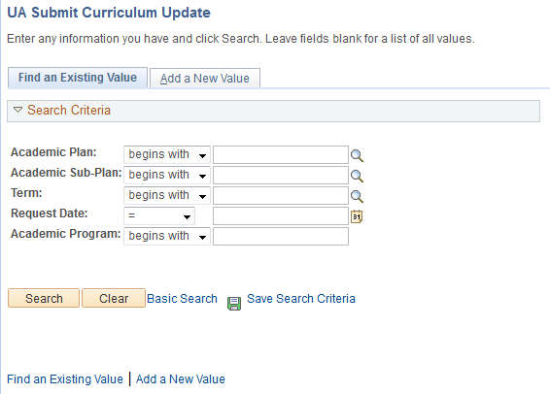

On this landing page:

Click **“Find an Existing Value”** to search for in-progress submissions (i.e. you have started the process and have yet to submit it to Curricular Affairs)

Click **“Add a New Value”** for submitting new updates

When adding a new value, enter the plan code, the sub-plan code (if needed), and the term when the updates are due**\***. You can click on the  icon next to plan to see what plans you have access to and need to update. Once you have entered/selected the pertinent data, click “Add” to generate the Curriculum Update ADVIP.

**\*Note:** The term entered must be the term in which you are submitting the updates (not the term for when they should go in effect). For example, for Fall 2020 updates you would enter 2194 (Fall 2019) instead of 2204 (Fall 2020).

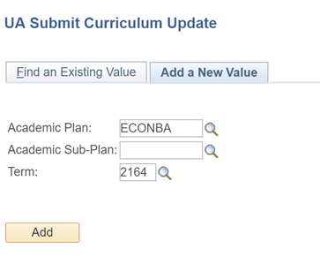

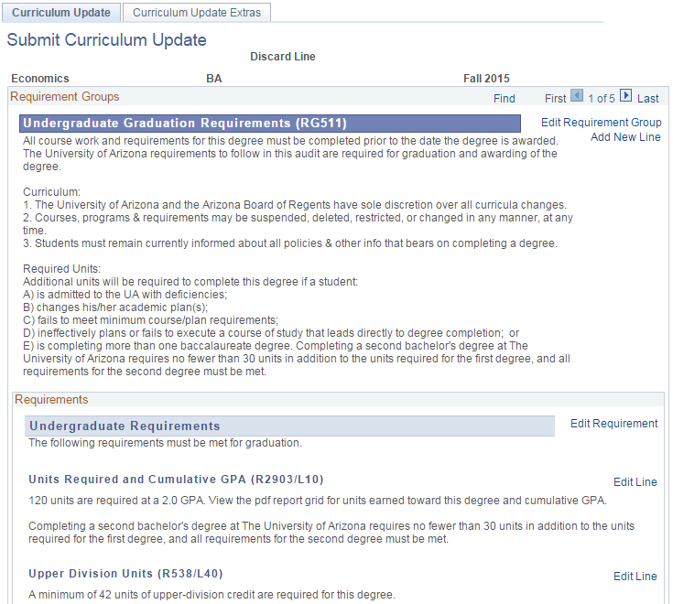

You will land on a page that looks similar to an online ADVIP. However, unlike the online ADVIP, the Curriculum Report is divided by pages via Requirement Group. To navigate to other areas of the ADVIP you will need to use the navigation arrows.

The report will display the major, degree, and term for the plan you have accessed. You will notice two tabs: Curriculum Update and Curriculum Update Extras. **Most of your work will be in the Curriculum Update tab.**

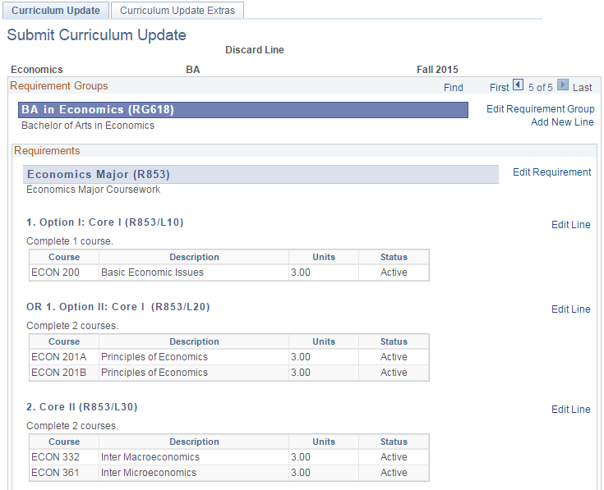

While using the **“Curriculum Update”** tab you have four options: Edit Requirement Group, Add New Line, Edit Requirement, and Edit Line. The Edit options involve changing the configuration / wording of existing requirements, while the “Add New Line” initiates a request for a new line to be added.

### Edit Line

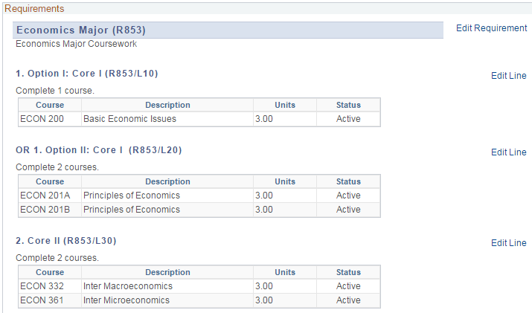

Click the “Edit Line” link next to the line you want to edit. For this example, we will click on Core II (R853/L30)

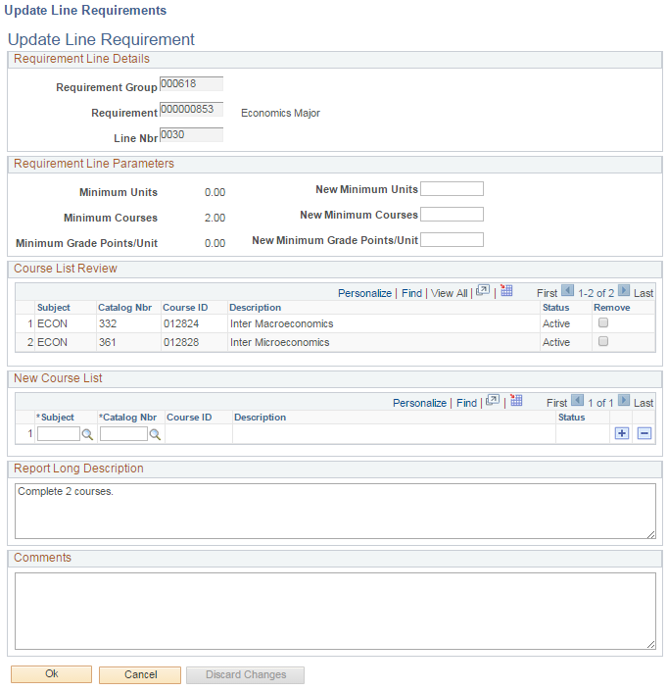

If changes to the minimum number of units, courses, or GPA are desired please indicate the new minimum in the appropriate new minimum box.

**Note**: GPA requests will go through a lengthier, more thorough review process. Such requests can be noted in the “Comments” box at the bottom of the page.

When you click “Edit Line” you will be taken to a new tab to provide the updates. You can confirm you are on the correct line by checking the information under the Requirement Line Details area.



The Course List Review Section displays active courses set to appear on the line. If any of those need to be removed, check the “Remove” box on the appropriate line.

If any courses need to be added to the line, add them under the “New Course List” section by looking up the courses using the search tool or by inputting the subject and catalog number. To add more courses use the + icon. Remove courses placed in error by using the – icon. Only active courses may be added. **Please note in the comments section if a course is unavailable.**

The Report Long Description box shows you the text that displays for the line on the ADVIP. **If you want to change the wording, please indicate that change in the “Comments” box.**

Use the comments box to tell us if a change needs to be made to the Report Long Description and if any changes need to be made to this line that you are unable to capture using the page functionality. If a line needs to be deleted, for example, you could put in the comments to “Delete this line.” You can also provide additional information or justification regarding this change if it seems prudent.

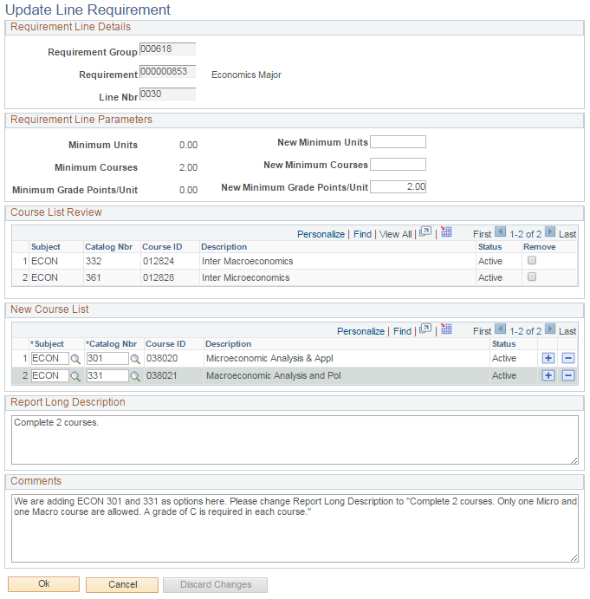

Once finished with the line updates, click “Ok” to add them to your update request. Click cancel if you do not wish to save the changes made on this page.

A completed Edit Line form would look like this . . .

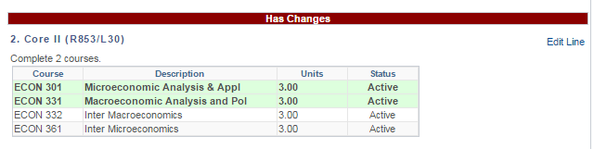

Once you have clicked “Ok” you will be taken back to the Curriculum Update Report. You will notice that the line has now been designated as having changes and that the new courses added on the line (they have not actually been added yet but are there for visual reference). Similarly, if courses are removed, they will appear in red with a strikethrough to indicate their removal from the line.

### Add New Line

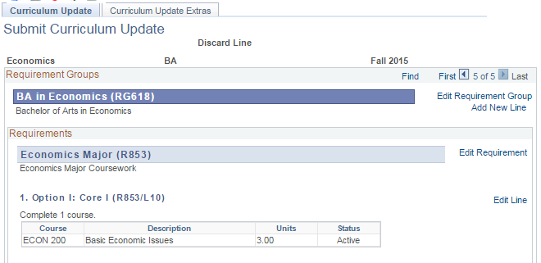

To request the creation of a new requirement line, please click “Add New Line” in the Requirement Groups box.

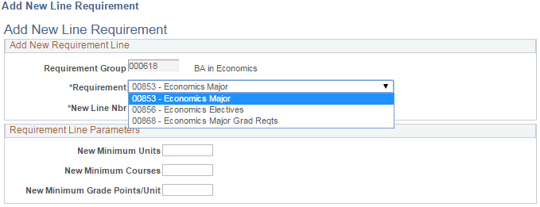

The Requirement Group will default to the RG on which you clicked “Add New Line” but you must select the Requirement where the new line should be added using the drop down menu.

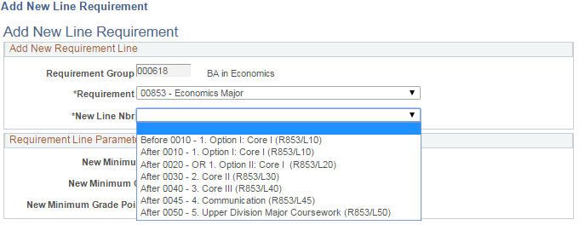

Once a Requirement is selected, identify where the new line should be placed on the report using the “New Line Nbr” drop down menu.

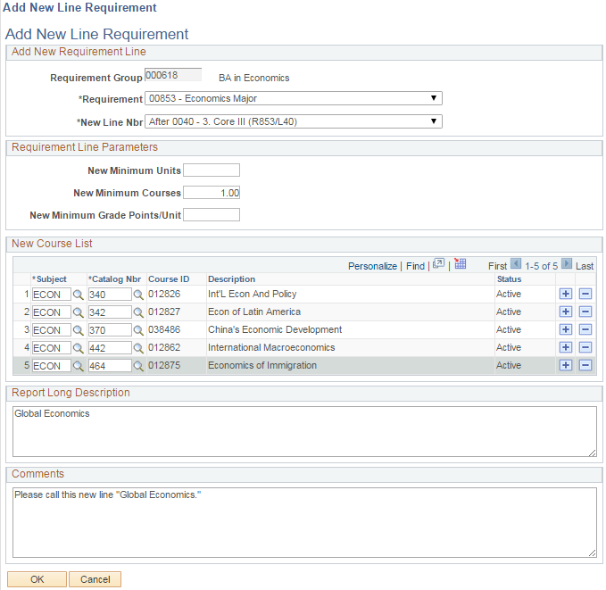

Add the new line parameters including minimum number of units or courses and the courses that should appear as options on the line. Please put your requested title for the line in the “Report Long Description” area. The “Comments” section can be used for various purposes, as stated previously. Click “Ok” when you are pleased with the setup.

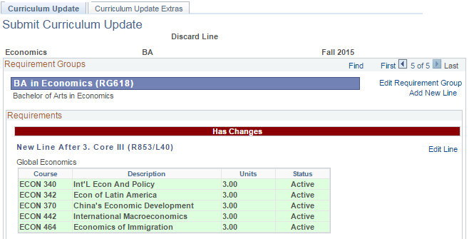

Once you have clicked “Ok” you will jump back to the update report and see the new line request at the top of the Requirement where it needs to be added.

### Edit Requirement

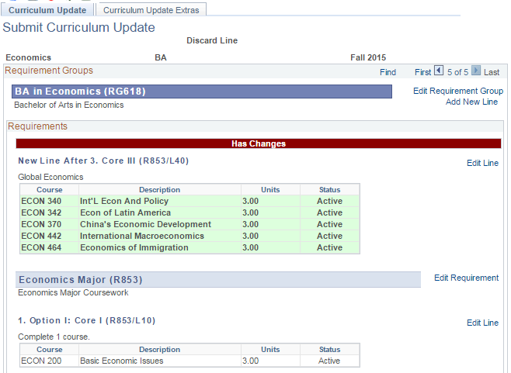

To make a change to a requirement click the “Edit Requirement” link next to the requirement you wish to update.

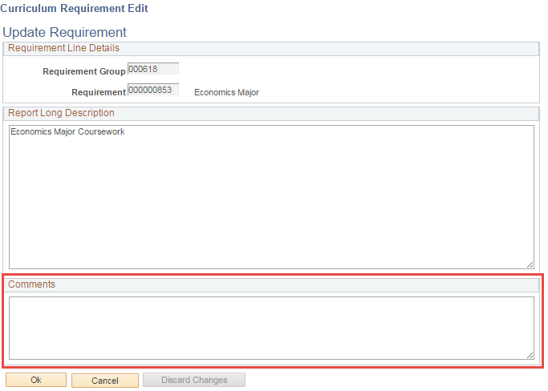

The “Edit Requirement” page is simple and will mostly be used for updating text on a particularly Requirement. Use the Comments area to explain any changes that you would like to be made.

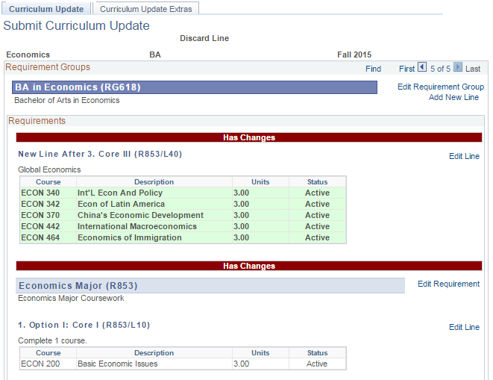

Once you click “Ok” to add the update request, you will bounce back to the update report, and you will see the note “Has Changes” at the Requirement level.

### Edit Requirement Group

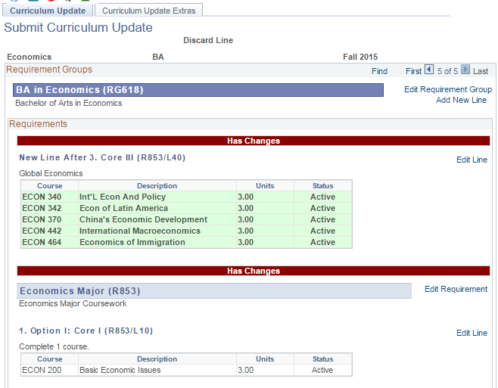

To make a change to a Requirement Group click the “Edit Requirement Group” link next to the requirement group.

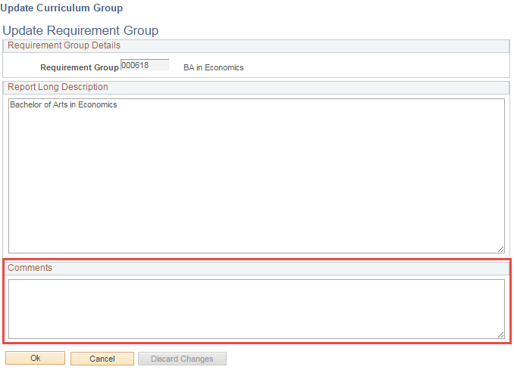

Like Requirements, you can only add comments to the “Update Requirement Group” field.

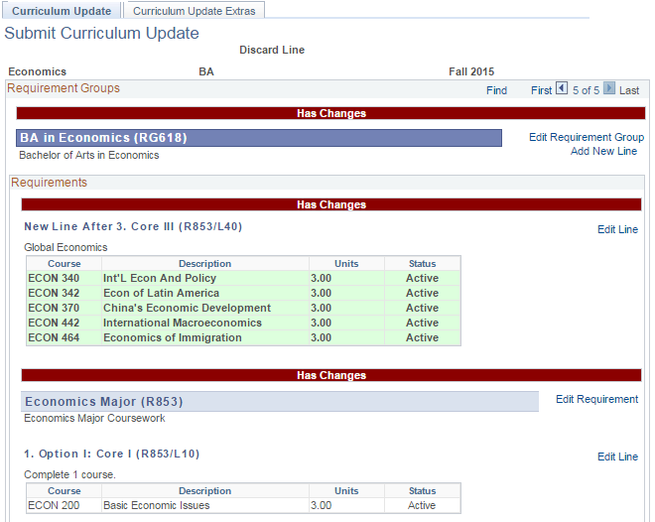

Once you click “Ok” to add the update request, you will bounce back to the update report, and you will see the note “Has Changes” at the Requirement Group level.

### Discarding or Editing an Update

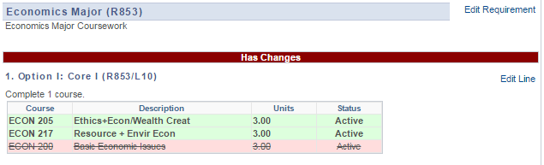

If for any reason you need to remove or change an update click the “Edit Line” link next to the line (or Edit Requirement or Edit Requirement Group).

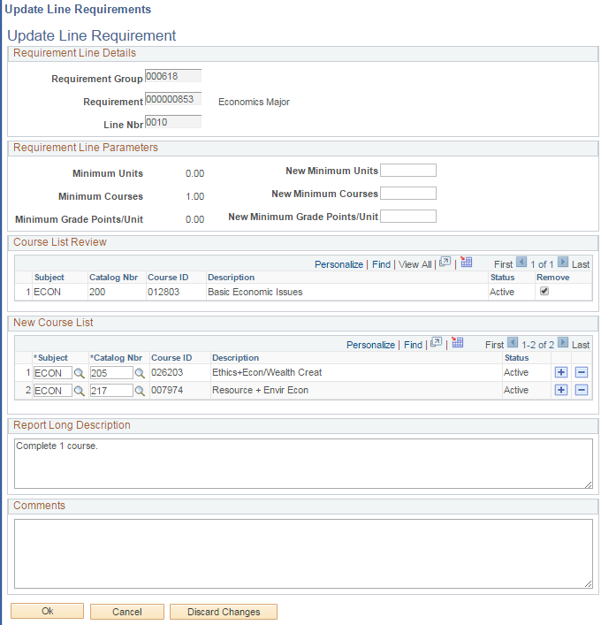

Clicking “Edit Line” (or Requirement or Requirement Group) will take you back to the update you previously made. Here, you can make any changes that are necessary or discard the update entirely (by clicking “Discard Changes”). You will be given a warning message which you can accept if you are sure you want to proceed with the deletion. Note: clicking Discard Changes will permanently delete the contents of the line, new line, requirement, or requirement group entry.

Once discarded, the line will revert to its original form, and the red line will indicate that the line “Doesn’t Have Changes.”

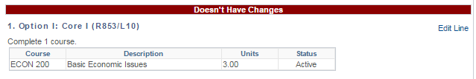

### Curriculum Update Extras Tab

The Curriculum Update Extras tab gives you more options for creating and submitting your update.

Use the text field for the following:

* Updates to the Major Description which appears at the top of the Advisement Report and on the Degree Search website.
* Overall comments that might not be captured elsewhere.

Use the File Attachments section for the following:

* Files that may be useful to capture your requested updates.
* Emails/letters of support from department head(s) for courses not owned by your department.
* Updates to your Degree Search 4-Year Plan (see “Degree Search Updates Guide” for details).

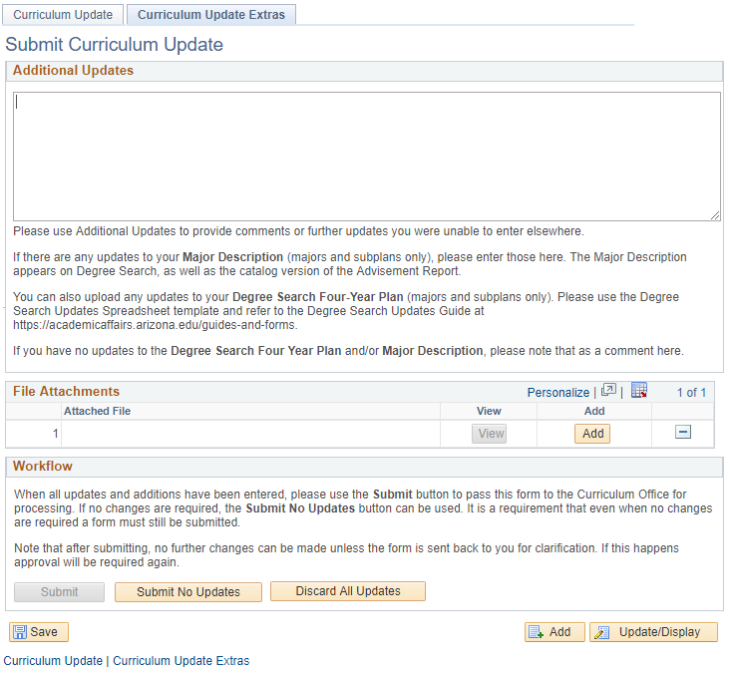

If your plan needs no updates, click the “Submit No Updates” button.

If you want to start completely over, click “Discard All Updates” to delete all the updates for the major / minor that have been created.

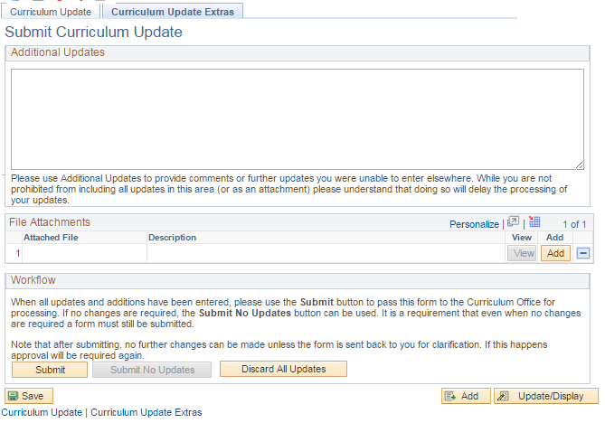

### Submitting Updates After the Deadline

**Clicking “Submit” indicates you are done with your updates and are ready for them to be reviewed by Curricular Affairs**.

Clicking “Save” retains the updates you have made so you can continue working on them later. **Saved items are not submitted and will not be sent to Curricular Affairs for review**. Make sure to return and submit the updates before the deadline!

It is important that you submit your curriculum updates on time. If you submit your update past the deadline stipulated you will be prompted to justify why these updates should be made and provide reasoning for their tardiness.

In such cases, you will see a pop-up warning alerting you to the missed deadline when you try to access your plan. Please read the warning and click “Ok” when finished.

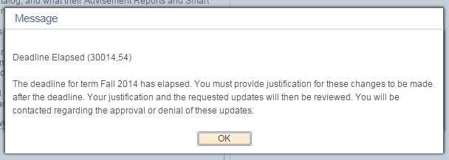

You will see a statement regarding the importance of curricular deadlines, and you will then have access to a text box where you can explain your justification for why the tardy updates should be accepted. Provide your justification and click “Ok” to proceed to request updates.

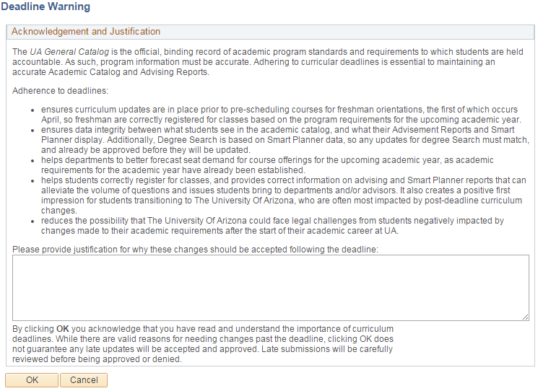

# Reviewing Curriculum Updates in UAccess

Navigation: UAccess Administrative Staff >Navigator > Curriculum Management > UA Curriculum Management > UA Curriculum Update > UA Review Curriculum Update

Curriculum Requesters/Reviewers can access the Review pages to see comments on updates or to see what was submitted.

Use the search fields to locate a plan. Access to the plans is managed by security, so unless you have “All Access” you should only see the plans you are assigned in the search results that have been submitted.

Please note, that the User ID field displays your user ID and not the ID of the individual who submitted the update. Do not be alarmed if you see your ID listed next to a plan you did not submit.

To access a plan, simply click on the appropriate link.

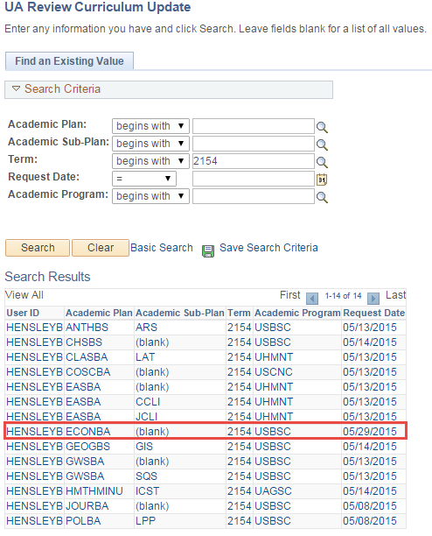

Group/Req/Line Edit Tab:

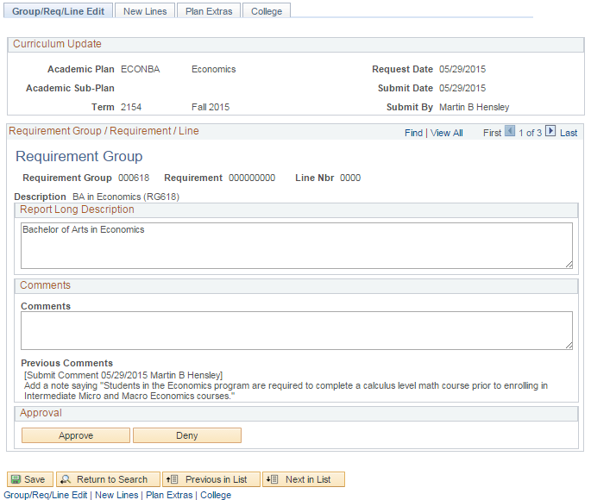

The Curriculum Update box will give you an overview of the plan you are reviewing, submission date, and submitter.

Use the navigation arrows to view other updates included in this submission.

When you access a plan, you will land on the first of four tabs, which is the “Group/Req/Line Edit” tab. On this tab you can review submitted Requirement Group, Requirement, and Line edits.

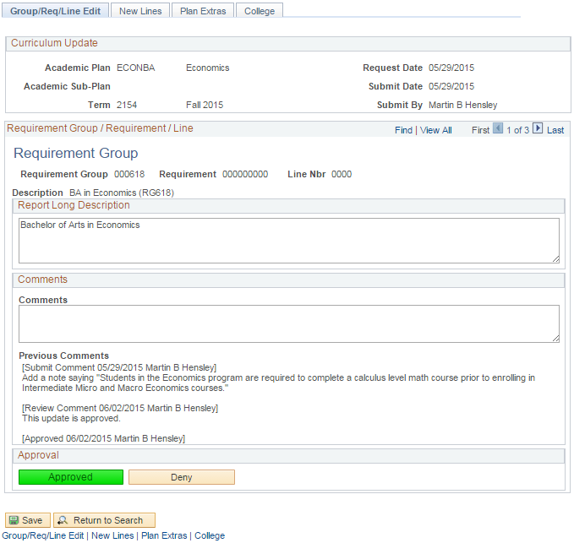

Comments included on the updates will appear under the “Previous Comments” area. New comments can be added by adding them to the comment box and clicking “Save.” The comment will be added to the comments thread. Approvals and Denials are cataloged here.

The “Requirement Group/Requirement/Line” box will display data on the update you are viewing. Because this is a RG the R and L numbers are null.

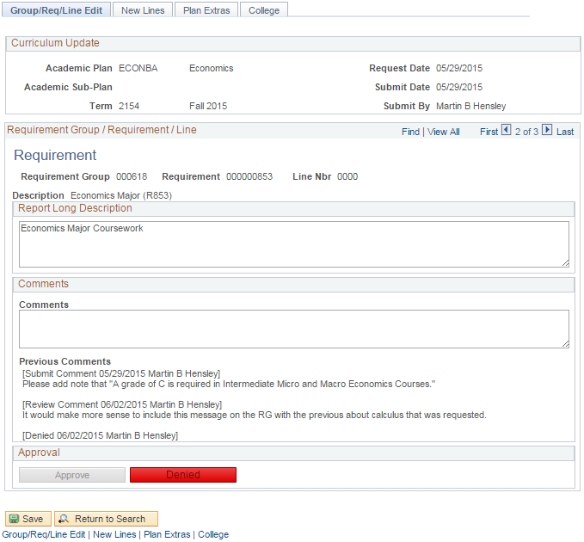

Comments can be added by inputting text in the Comments box and saving the page. For this example, the update was denied.

Here we have moved to an update submitted for a Requirement. Again, the Line Nbr value is null since this is an update to a Requirement.

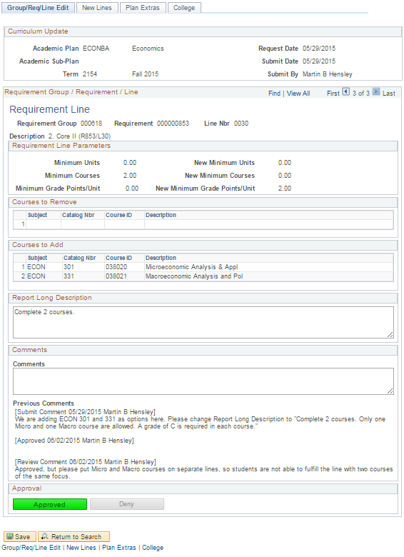

Courses requested to be added or removed from the line will display.

Comments can be added by inputting text in the Comments box and saving the page.

Requested line parameter changes will display here.

For the line edit, the RG/R/L fields will all be populated.

### New Lines Tab

The new lines tab allows the user to review any new line requests that were submitted.

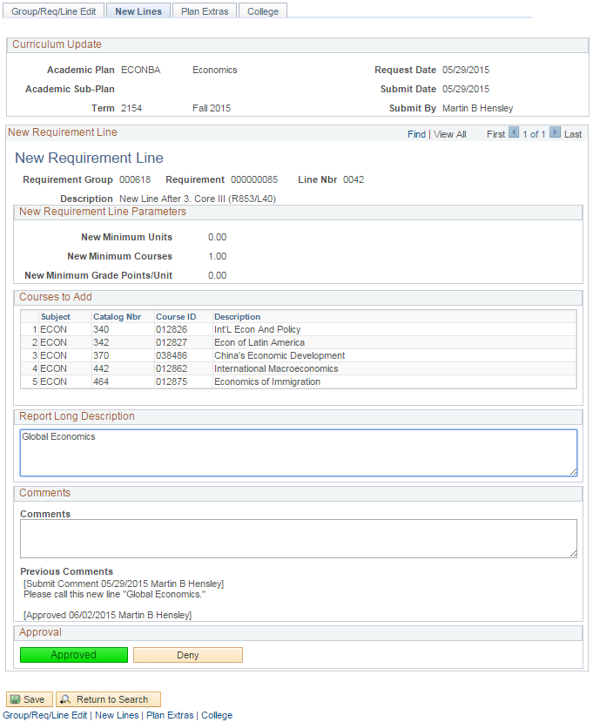

The requested line parameters and the course list are included.

The New Lines tab and page look similar to the “Edit Line” page. The Description indicates where the new line should go in the Req.

### Plan Extras Tab

The Plan Extras tab corresponds to the Curriculum Update Extras tab on the submission form. Here the user can see and add any overall comments for the plan and view attached files, if any. Because no file was attached to the ECONBA update in our example, the view file box is not present.

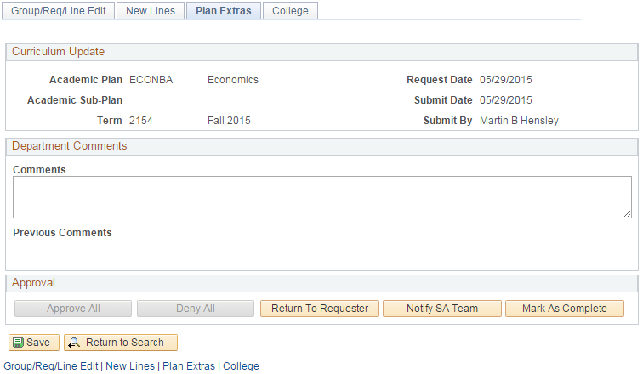

Depending on previous actions, some or all of the actions available in the “Approval” box will be available. If the user has consistently Approved or Denied or not stipulated either on *all* of the updates the option will be available for the approver to “Approve All” or “Deny All.” Because, in our example, there are both approvals and denials, those options are not available.

The approver also has the option to “Return to Requester,” “Notify SA Team,” and “Mark As Complete.”

* *Return to Requester*: if the reviewer finds issues with the requested updates or something is unclear, he/she can use this option to “assign” the update back to the individual who submitted this. An automated message will go out indicating the requester needs to respond to the reviewer’s comments. The original requester will have access to the plan again at UAccess Administrative Staff >Navigator > Curriculum Management > UA Curriculum Management > UA Curriculum Update > UA Submit Curriculum Update. The requester will need to locate the plan using the search function on UA Submit Curriculum Updates page (it will be available again as if it were saved and not submitted). The requester should add and save comments for the reviewer to see and then resubmit the update.
* *Notify SA Team*: if the reviewer does not find issues or have questions regarding the update he/she can send assign to the SA Team so the updates can be implemented on the Advisement Reports. An email goes out to the requester and the SA Team when this status is selected.
* *Mark As Complete*: if no updates are needed the reviewer in Curricular Affairs can mark the update as complete. In most situations, the SA Team will be the ones to indicate when an update is complete. When an update is marked as complete an automated email will go out to Curricular Affairs, SA Team, and the requester.

### College Tab

The college tab will be accessible for deans, associate deans, or dean’s office administrative personnel who want to be able to review the curriculum update requests for their college. Users gain access to this page by having the Curriculum College Approver role and being assigned a college in the college security table. Users can add comments and provide an overall approval or denial—they do not have line item approval or denial authority. This is an ancillary process and curricular approvals and building will not be held for college approval.

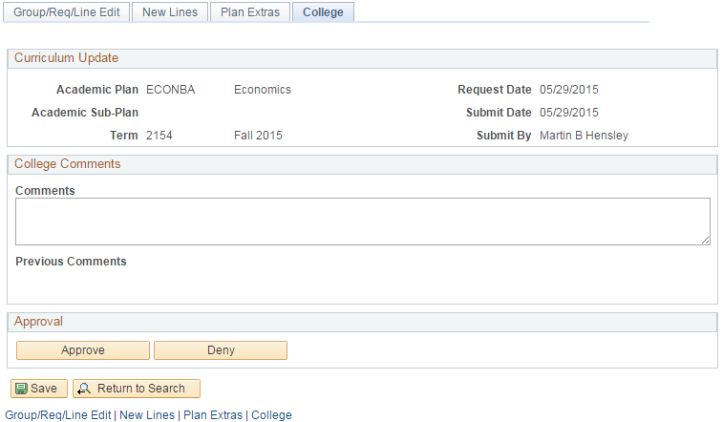

# Viewing Archived Curriculum Updates

Navigation: UAccess Administrative Staff >Navigator > Curriculum Management > UA Curriculum Management > UA Curriculum Update > UA Archived Curriculum Update

Users can view archived versions of their curriculum updates to ensure the updates they requested were implemented or if questions arise regarding requested updates. Navigate to the appropriate page and provide search criteria to locate the archived plan update.

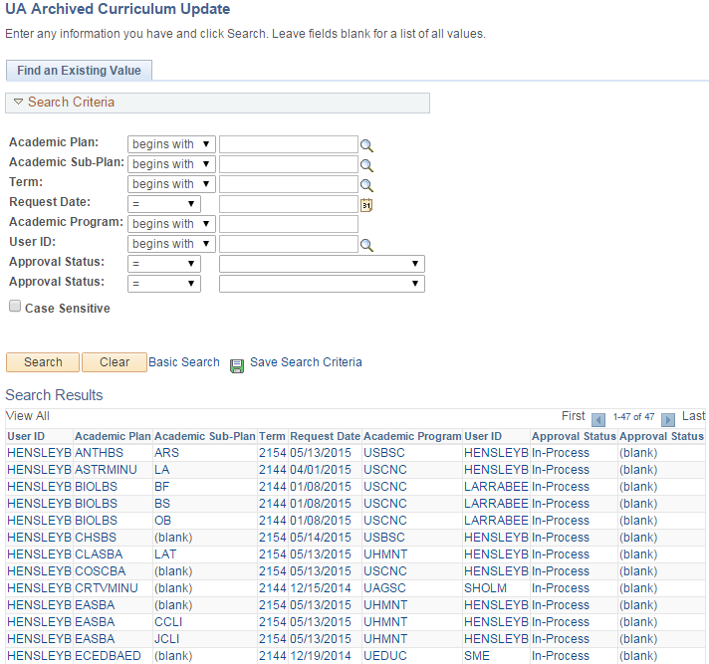

The archived curriculum reports look like the review pages, but are view only. Comments cannot be added and status cannot be changed.

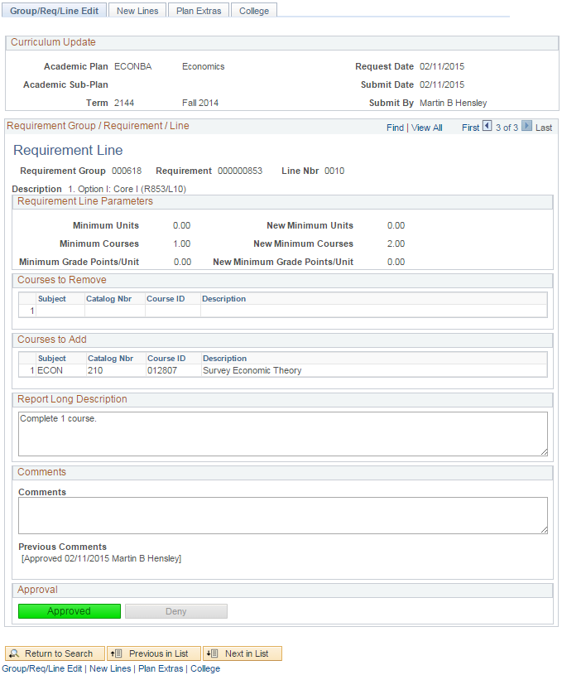

# Viewing Curriculum Updates Statistics

Navigation: UAccess Administrative Staff >Navigator > Curriculum Management > UA Curriculum Management > UA Curriculum Update > UA Curriculum Update Stats

Users can view the status of plans using various parameters on this page. You can jump immediately to a plan by using the “View” link on a plan’s line. When you leave this page, you will be asked of you want to save. Please cancel through that message.

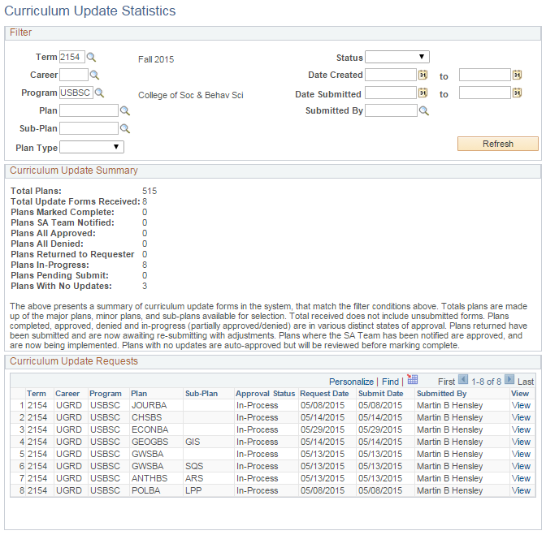

# Viewing Academic Requirements

Navigation: UAccess Administrative Staff >Navigator >Academic Advisement >Academic Requirements >Define Academic Requirements

Users can view details about how a line is built that are otherwise not visible on an Academic Advisement Report. Main areas of interest would be how a line is capturing the units (All Stats or Verify), whether a limit line has been built, and if a Requirement has any hidden lines.

Curriculum Requesters will have view access only, and will not be able to make edits to this area.

Use the search fields in the “Find an Existing Value” tab to locate a Requirement.

“Requirement Usage” should be entered as ADV.

“Academic Requirement” is the Requirement (or R) number. In this case, we’re looking for detail on (R853/L10) from the ECONBA plan.

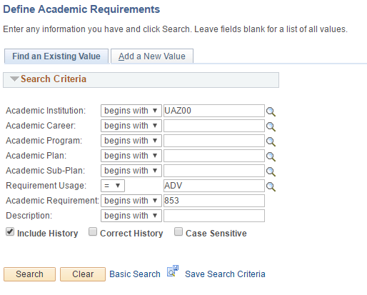

### Line Item Parameters Tab

This tab shows information about how a line is structured.

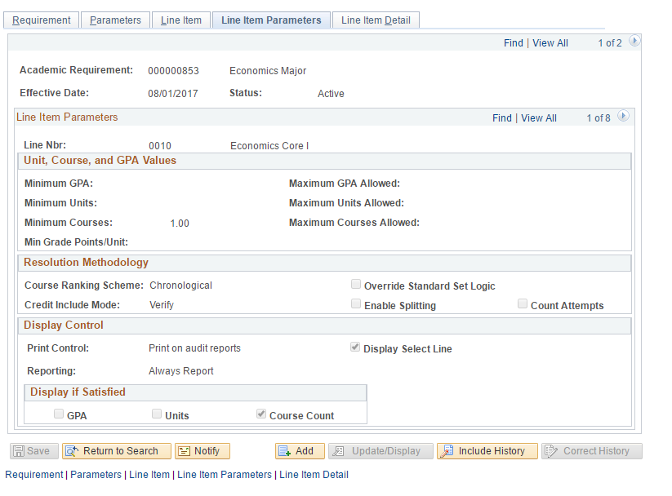

Verify lines check that a course has been met, but do not pull the units/course to the line. Verify lines “share” the course. Examples of verify lines: major/minor units, MCWA, Diversity Emphasis, and Additional Coursework.

Line Parameters (visible on Advisement Report)

Line Number

(arrow right or “View All” to see all lines)

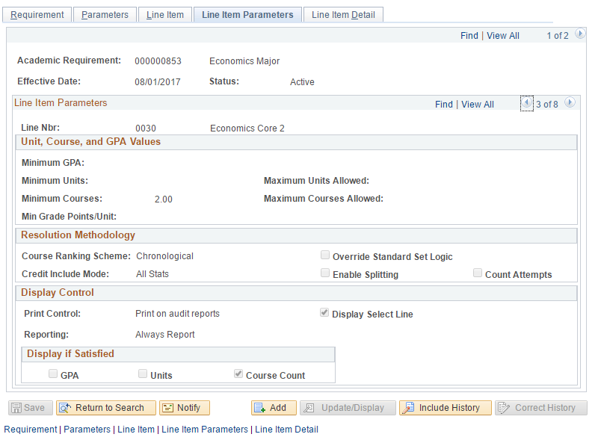

All Stats lines pull in units/courses to the line and do not share. This type of line pulls a course to the first unsatisfied line that it can fulfill. Most general education, majors, and minors utilize All Stats lines as those courses should not be double used elsewhere.

### Hidden Line

The image below is an example of a hidden line. This line acts as any visible line would, with its own parameters and course list, but is not printed automatically on an Advisement Report. In most cases, lines should be visible to students so that their options and requirements are known to them. A department may opt to use a hidden line for courses that will satisfy a requirement, but are not commonly used or available to students (example: a course number that UA does not offer, but has been articulated for transfer credit). This prevents students trying to enroll in unavailable courses and does not require advisors to make an exception when the course is used.

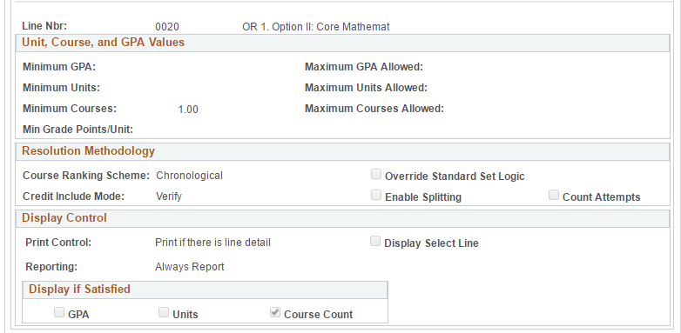

Indicates this line will only print (show on the Advisement Report) if/when it has been satisfied. If a student completes the visible line option, they will not see that the hidden line is not satisfied.

### Line Item Tab

The Line Item Tab shows information about lines’ type and descriptions. Here, users can also see how lines are “connected.” Most lines are connected via “And” which indicates “Also Required” but “Or” connectors indicate that options are available for a specific requirement.

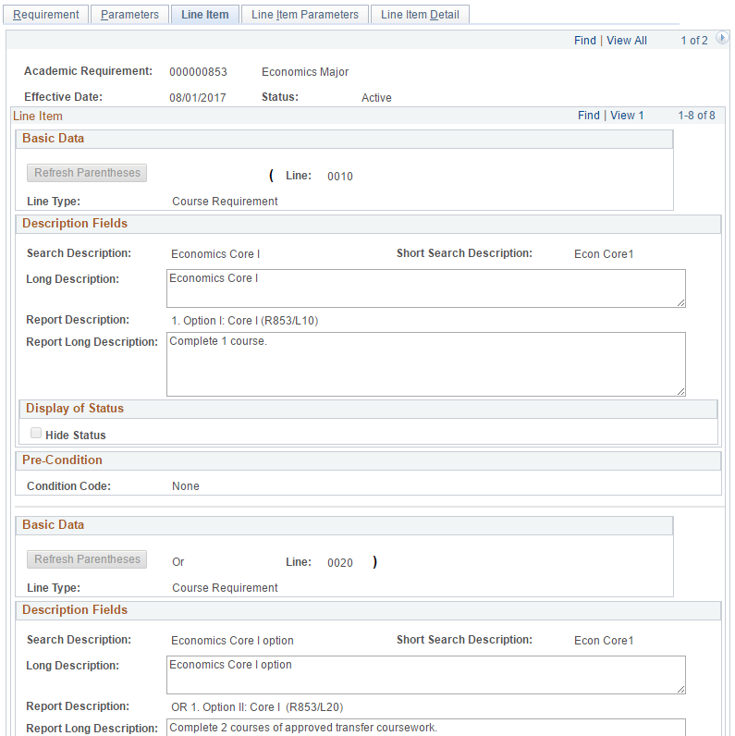

Parentheses indicate lines are connected as options. “Or” indicates that students are required to complete one of the lines within parentheses to satisfy the course requirement. Once one option line is completed, only that line will appear on the Advisement Report; until then, all options will be shown.

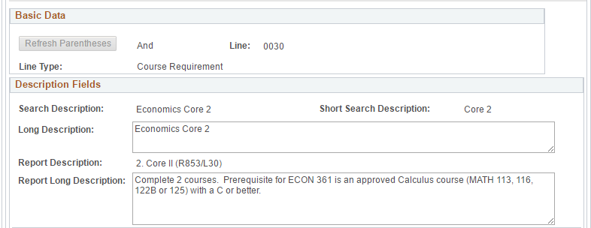

Most lines are connected via “And” which indicates “Also Required”

The “Report Description” and “Report Long Description” are the text displays for each line printed on the Advisement Report.

### Limit Line

The image below is an example of a limit line. This line is not printed on the Advisement Report (so it is also “hidden”), but sets a limit on course use for the Requirement. If a limit is exceeded, the excess courses will not count toward this area on the Advisement Report. A department may opt to implement a limit for a variety of reasons, but the most common is a limit on house-numbered units (Internships, Independent Studies, Directed Research, etc.).

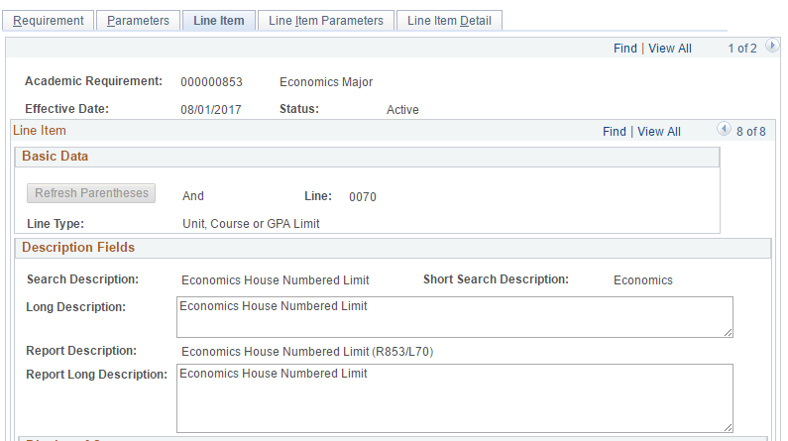

Description of the line; here, indicating that the limit is on units of house-numbered courses.

Indicates a limit line.

More information about the limit can also be viewed on the Line Item Parameters tab. Here, users can view the specifics of the limit, whether a certain GPA, or number of units or courses.

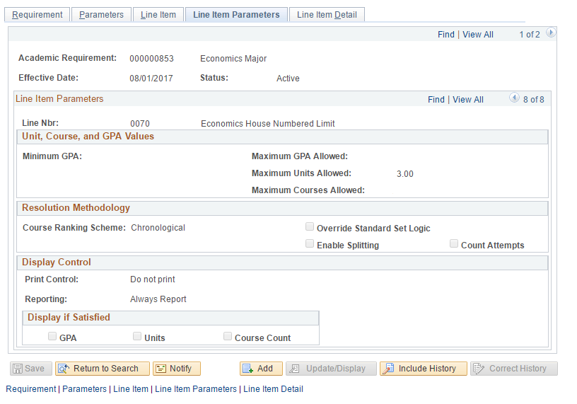

Indicates the limit; in this case, 3 units maximum of any course included in the Course List. If a student exceeds the limit, the excess units will not be included.

Indicates that this line is not visible on Advisement Reports.

# Viewing Course Lists

Course lists are the course options listed for students on each line of an Advisement Report, whether hidden or visible. They are created as individual objects, each with a number, so that the same course list may be used for multiple lines across multiple Advisement Reports, as needed. Users can view the contents of a course list by referencing this number.

### Line Item Detail Tab

To find a course list number, navigate to the “Line Item Detail” tab in “Define Academic Requirements.”

This is the same limit line (R853/L70) from the previous page.

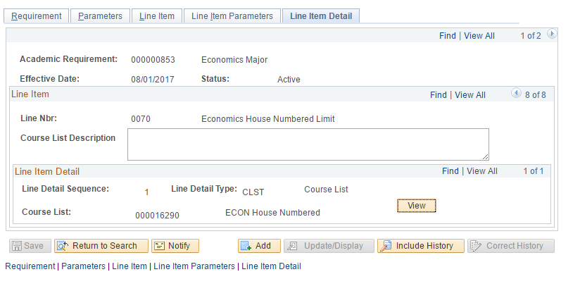

Course lists may be one list (as in this case) or there may be multiple lists.

With multiple lists, they may be combined, or one list excluded from another.

This “View” button will result in an error. The next step will explain how to view a course list. For now, take note of the course list number.

Course list number and description.

### Define Course Lists

Navigation: UAccess Administrative Staff >Navigator >Academic Advisement >Academic Requirements >Define Course Lists

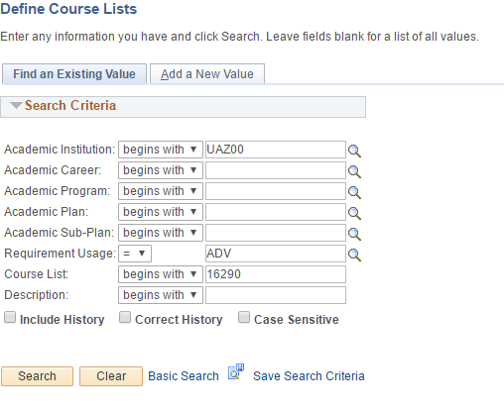

On the “Find an Existing Value” tab, use the following search criteria:

Academic Institution = “UAZ00”

Requirement Usage = “ADV”

Course List = the course list number

### Course List Detail Tab

This tab shows users the actual list of courses included in the Course List group. A Course List may list specific course numbers, WildCards, or a combination of both.

Here is an example of a Course List with WildCard courses:

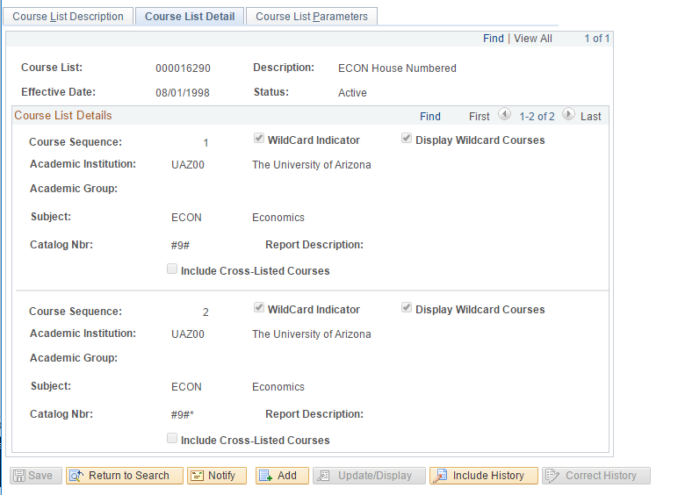

The “#” sign stands for any digit. This indicates use of any ECON course with a “9” as the second digit of the course number, i.e. ECON 393 or ECON 499.

The asterisk (*) indicates that any letter may also follow the course number, i.e. ECON 498H.

Indicates WildCard, which is any course that meets certain subject and catalog number criteria. Courses that meet criteria will be displayed on the Advisement Report.

Here is an example of a Course List with specific courses listed:

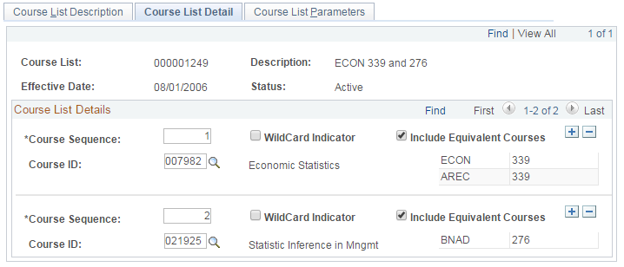

Equivalent courses (courses with the same Course ID) must be included, and will be shown here.