NEW ACADEMIC PROGRAM-UNDERGRADUATE MAJOR
ADDITIONAL INFORMATION FORM

- MAJOR DESCRIPTION -provide a marketing/promotional description for the proposed program. Include the purpose, nature, and highlights of the curriculum, faculty expertise, emphases (sub-plans; if any), etc. The description will be displayed on the advisement report(s), Degree Search, and should match departmental and college websites, handouts, promotional materials, etc.

- NEED FOR THE MAJOR/JUSTIFICATION-describe how the major fulfills the needs of the city, state, region, and nation. Provide market analysis data or other tangible evidence of the need for and interest in the proposed major (and emphases, if applicable). This might include results from surveys of current students, alumni, and/or employers or reference to student enrollments in similar programs in the state or region. Include an assessment of the employment opportunities for graduates of the program for the next three years. Curricular Affairs can provide a job posting/demand report by skills obtained/outcomes/CIP code of the proposed major. Please contact Martin Marquez to request the report for your proposal.

- MAJOR REQUIREMENTS– complete the table below by listing the major requirements, including required number of units, required core, electives, and any special requirements, including emphases* (sub-plans), thesis, internships, etc. Note: information in this section must be consistent throughout the proposal documents (comparison charts, four year plan, curricular/assessment map, etc.). Delete the EXAMPLE column before submitting/uploading. Complete the table in Appendix A if requesting a corresponding minor.
Total units required to complete the degree |  | EXAMPLE  120
Upper-division units required to complete the degree |  | 42
Foundation courses
Second language |  | 2nd Semester Proficiency
Math |  | G-Strand
General education requirements |  | 2 courses/ 6 units- Tier I 150 (INDV)  2 courses/ 6 units-Tier I 160 (TRAD)  2 courses/ 6 units-Tier I 170 (NATS)  3 units-Tier II Arts  1 course/ 3 units-Tier II Humanities  1 course/ 3 units-Tier II Individuals and Societies  0 courses/0 units-Tier II Natural Sciences (per college exception)
Pre-major? (Yes/No). If yes, provide requirements. Provide email(s)/letter(s) of support from home department head(s) for courses not owned by your department. |  | Yes. Complete the following coursework:  -CHEM 151 (4) General Chemistry I  -CHEM 152 (4) General Chemistry II  Complete 1 course from the following:  -PHYS 140 (3) Introductory Mechanics  -PHYS 141 (4) Introductory Mechanics
List any special requirements to declare or gain admission to this major (completion of specific coursework, minimum GPA, interview, application, etc.) |  | -Complete all pre-major coursework with 2.5 GPA.  -Complete interview with department.  -Submit career path vision statement.
Major requirements
Minimum # of units required in the major (units counting towards major units and major GPA) |  | 56
Minimum # of upper-division units required in the major (upper division units counting towards major GPA) |  | 38
Minimum # of residency units to be completed in the major |  | 18
Required supporting coursework (courses that do not count towards major units and major GPA, but are required for the major). Courses listed must include prefix, number, units, and title. Include any limits/restrictions needed (house number limit, etc.). Provide email(s)/letter(s) of support from home department head(s) for courses not owned by your department. |  | List all required supporting coursework.  -MATH 129 (3) Calculus II  Complete 1 of the following:  -PHYS 240 (3) Introductory Electricity and Magnetism  -PHYS 241 (4) Introductory Electricity and Magnetism
Major requirements. List all major requirements including core and electives. If applicable, list the emphasis requirements for each proposed emphasis*. Courses listed count towards major units and major GPA. Courses listed must include prefix, number, units, and title. Mark new coursework (New). Include any limits/restrictions needed (house number limit, etc.). Provide email(s)/letter(s) of support from home department head(s) for courses not owned by your department. |  | List all required major coursework.  For example:  Fire Services Core: Complete 2 courses (6 units)  -(New)FIRE 345 (3) Introduction to Fire  -(New) FIRE 346 (3) Advanced Fire  Fire Management Electives: Complete 18 units from the following. Limit of 6 units from house-numbered coursework may be used towards this requirement :  Select one emphasis from:  Fire Management  Fire Safety Education  General
Internship, practicum, applied course requirements (Yes/No). If yes, provide description. |  | Yes. Complete 6 units:  FIRE 493 (6) Fire Fighting Internship. Students complete internship at a fire station.
Senior thesis or senior project required (Yes/No). If yes, provide description. |  | Yes. Complete 6 units:  FIRE 498 (6) Fire Senior Thesis
Additional requirements (provide description) |  | -Present Senior Thesis and Internship experience at departmental conference.
Minor (specify if optional or required) |  | Optional
Any double-dipping restrictions (Yes/No)? If yes, provide description. |  | Yes, major core courses not permitted to double-dip.
*Emphases are officially recognized sub-specializations within the discipline. ABOR Policy 2-221 c. Academic Degree Programs Subspecializations requires all undergraduate emphases within a major to share at least 40% curricular commonality across emphases (known as “major core”). Total units required for each emphasis must be equal. Proposed emphases having similar curriculum with other plans (within department, college, or university) may require completion of an additional comparison chart. Complete the table found in Appendix B to indicate if emphases should be printed on student transcripts and diplomas.

- CURRENT COURSES–using the table below, list all existing courses included in the proposed major. You can find information to complete the table using the UA course catalog or UAnalytics (Catalog and Schedule Dashboard> “Printable Course Descriptions by Department” On Demand Report; right side of screen). If the courses listed belong to a department that is not a signed party to this implementation request, upload the department head’s permission to include the courses in the proposed program and information regarding accessibility to and frequency of offerings for the course(s). Upload letters of support/emails from department heads to the “Letter(s) of Support” field on the UAccess workflow form. Add rows to the table, as needed.
Course prefix and number (include cross-listings) | Units | Title | Course Description | Pre-requisites | Modes of delivery (online, in-person, hybrid) | Typically Offered  (F, W, Sp, Su) | Dept signed party to proposal? (Yes/No)

- NEW COURSES NEEDED – using the table below, list any new courses that must be created for the proposed program. If the specific course number is undetermined, please provide level (ie CHEM 4**). Add rows as needed. Is a new prefix needed? If so, provide the subject description so Curricular Affairs can generate proposed prefix options.
Course prefix and number (include cross-listings) | Units | Title | Course Description | Pre-requisites | Modes of delivery (online, in-person, hybrid) | Status* | Anticipated first term offered | Typically Offered  (F, W, Sp, Su) | Dept signed party to proposal? (Yes/No) | Faculty members available to teach the courses
*In development (D); submitted for approval (S); approved (A)

Subject description for new prefix (if requested). Include your requested/preferred prefix, if any:

- FACULTY INFORMATION- complete the table below. If UA Vitae link is not provided/available, attach a short CV (2-3 pages) to the end of the proposal or upload to the workflow form (in the “Letter(s) of Support” field). UA Vitae profiles can be found in the UA directory/phonebook. Add rows as needed. Delete the EXAMPLE rows before submitting/uploading. NOTE: full proposals are distributed campus-wide, posted on committee agendas and should be considered “publicly visible”. Contact Pam Coonan and Martin Marquez if you have concerns about CV information being “publicly visible”.
Faculty Member | Involvement | UA Vitae link or “CV attached”
EX: Joan Smith | Teach FIRE 388 | CV attached
EX: Mike Smith | Teach FIRE 387, Faculty advisor, Internship supervisor | UA Vitae Link

- FOUR-YEAR PLAN – provide a sample four-year degree plan that includes all requirements to graduate with this major and takes into consideration course offerings and sequencing. Refer to Degree Search for examples. Use generic title/placeholder for requirements with more than one course option (e.g. Upper Division Major Elective, Minor Course, Second Language, GE Tier 1, GE Tier 2). Add rows as needed.
Semester 1 |  | Semester 2 |  | Semester 3 |  | Semester 4
Course prefix and number | Units | Course prefix and number | Units | Course prefix and number | Units | Course prefix and number | Units
Total |  | Total |  | Total |  | Total
Semester 5 |  | Semester 6 |  | Semester 7 |  | Semester 8
Course prefix and number | Units | Course prefix and number | Units | Course prefix and number | Units | Course prefix and number | Units
Total |  | Total |  | Total |  | Total

- STUDENT LEARNING OUTCOMES AND CURRICULUM MAP—describe what students should know, understand, and/or be able to do at the conclusion of this major. Work with Office of Instruction and Assessment to create a curricular map using Taskstream. Include your curricular map in this section (refer to Appendix C for sample Curriculum Map generated using Taskstream).

EMPHASIS LEARNING OUTCOMES – at minimum, provide two unique learning outcomes for each proposed emphasis. Which courses will Introduce, Practice, and/or Assess the learning outcomes? Use the table below to provide the information. Add rows as needed. Delete this section and table if the proposed major does not include emphases.
Emphasis | Learning Outcome | Introduced | Practiced | Assessed
EX: Fire Management | Students will be able to…. | FIRE 378 | FIRE 381 | FIRE 388

Curriculum Map:

- ASSESSMENT PLAN FOR STUDENT LEARNING- using the table below, provide a schedule for program assessment of intended student learning outcomes 1) while students are in the program and 2) after completion of the major. Add rows as needed. Delete EXAMPLE row.

Learning Outcomes | Sources(s) of Evidence | Assessment Measures | Data Collection Points
EXAMPLE: Outcome 1: Discern ethical problems, ambiguities, controversies, and assumptions in … | Course-embedded assessments  Pre-post student reflection essays; exit surveys; student focus group; alumni surveys | Exams, papers, and other forms of student work  Summative critical self-reflections | End of each course  End of CHEM 4** course

- PROGRAM ASSESSMENT PLAN- using the table below, provide a schedule for program evaluation 1) while students are in the program and 2) after completion of the major. Add rows as needed. Delete EXAMPLE rows.

Assessment Measure | Source(s) of Evidence | Data Collection Point(s)
EXAMPLE: Job Placement Statistics | Student/Alumni Survey | At graduation and as part of alumni survey
EXAMPLE: Academic Program Review | Reviewers’ responses | Every 7 years

- ANTICIPATED STUDENT ENROLLMENT-complete the table below. What concrete evidence/data was used to arrive at the numbers?
5-YEAR PROJECTED ANNUAL ENROLLMENT
 | 1st Year | 2nd Year | 3rd Year | 4th Year | 5th Year
Number of Students

Data/evidence used to determine projected enrollment numbers:

- ANTICIPATED DEGREES AWARDED- complete the table below, beginning with the first year in which degrees will be awarded. How did you arrive at these numbers? Take into consideration departmental retention rates. Use National Center for Education Statistics College Navigator to find program completion information of peer institutions offering the same or a similar program.
PROJECTED DEGREES AWARDED ANNUALLY
 | 1st Year | 2nd Year | 3rd Year | 4th Year | 5th Year
Number of Degrees

Data/evidence used to determine number of anticipated degrees awarded annually:

- PROGRAM DEVELOPMENT TIMELINE- describe plans and timelines for 1) marketing the major and 2) student recruitment activities.

- DIVERSITY AND INCLUSION-describe how you will recruit diverse students and faculty to this program. In addition, describe retention efforts in place or being developed in order to retain students.

- ABOR REQUIREMENT: New Academic Program Request. This section is required by ABOR. Most of the information can be copied/pasted from completed sections above. Instructions/clarification for completing the table below, from ABOR, can be viewed/downloaded here.
University: University of Arizona

Name of Proposed Academic Program:

Academic Department:

Geographic Site:

Instructional Modality:

Total Credit Hours:

Proposed Inception Term:

Brief Program Description:

Learning Outcomes and Assessment Plan:

Projected Enrollment for the First Three Years:

Evidence of Market Demand:

Similar Programs Offered at Arizona Public Universities:

New Resources Required? (i.e. faculty and administrative positions; infrastructure, etc.):

Program Fee/Differentiated Tuition Required? YES NO Estimated Amount:

Program Fee Justification:

Specialized Accreditation? YES NO

Accreditor:

Appendix A. Minor Requirements. Complete if requesting a corresponding minor. Delete EXAMPLE column before submitting.

Minimum total units required |  | EXAMPLE  18
Minimum upper-division units required |  | 9
Total transfer units that may apply to the minor |  | 9
List any special requirements to declare/admission to this minor (completion of specific coursework, minimum GPA, interview, application, etc.) |  | -Meet with departmental interview committee  -Complete all pre-requisite coursework
Minor requirements. List all minor requirements including core and electives. Courses listed must include course prefix, number, units, and title. Mark new coursework (New). Include any limits/restrictions needed (house number limit, etc.). Provide email(s)/letter(s) of support from home department head(s) for courses not owned by your department. |  | List all required coursework.  For example:  Actuary core:  Complete 2 courses (6 units):  -(NEW) ACTU 123 (3) Introduction to Actuarial Sciences  -(NEW) ACTU 345 (3) Advanced Actuarial Methods  Actuary Electives: Complete 12 units from the following:
Internship, practicum, applied course requirements (Yes/No). If yes, provide description. |  | Yes. Complete 3 units of internship or practicum with a local firm.
Additional requirements (provide description) |  | Complete and submit “Actuary Minor Reflection Paper”
Any double-dipping restrictions (Yes/No)? If yes, provide description. |  | Yes, minor coursework may not double dip with another minor.

Appendix B. Emphasis Print Information-if applicable, complete the table below to indicate if proposed emphases should be printed on transcript and diploma. Add rows as needed. Note: emphases are displayed on transcript and diplomas as “ _______ Emphasis”. Delete EXAMPLE row before submitting.

Emphasis | Print on transcript | Print on diploma
EX: Fire Safety | Yes | Yes

Appendix C. Sample Curriculum Map for BA in Statistics and Data Science. Created using taskstream. Contact OIA for assistance in creating your curriculum map.
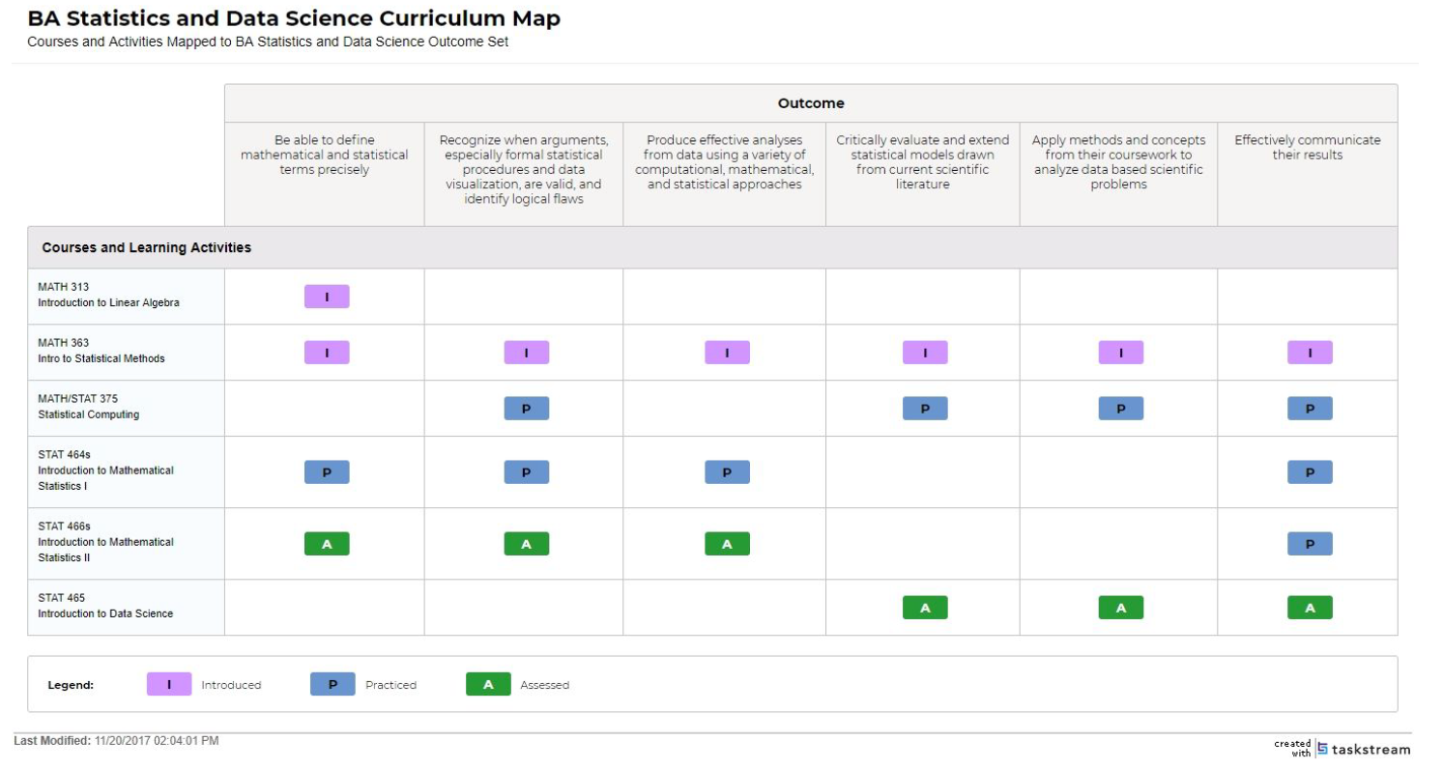

Appendix B. Assessment Plan for Student Learning

