NEW ACADEMIC PROGRAM- STANDALONE GRADUATE MINOR
ADDITIONAL INFORMATION FORM

- MINOR DESCRIPTION -provide a marketing/promotional description for the proposed minor. Include the purpose, nature, and highlights of the curriculum, faculty expertise, etc. The description should match departmental and college websites, handouts, promotional materials, etc.

- NEED FOR THE MINOR/JUSTIFICATION-provide market analysis data or other tangible evidence of the need for and interest in the proposed minor. This might include results from surveys of current students, alumni, and/or employers or reference to student enrollments in similar programs in the state or region. Curricular Affairs can provide a job posting/demand report by skills obtained/outcomes of the proposed minor. Please contact the Office of Curricular Affairs to request the report for your proposal.

- MINOR REQUIREMENTS– complete the table below to list the minor requirements, including minimum number of credit hours, required core, electives, and any special requirements. Note: information in this section must be consistent throughout the proposal documents (comparison charts, curricular/assessment map, etc.). Delete the EXAMPLE column before submitting/uploading.
Minimum total units required |  | EXAMPLE  13
Total transfer units that may apply to minor |  | 3
Pre-admissions expectations (i.e. academic training to be completed prior to admission) |  | Active graduate student with a background/training in field; statement of purpose
Minor requirements. List all minor requirements including core and electives. Courses listed must include course prefix, number, units, and title. Mark new coursework (New). Include any limits/restrictions needed (house number limit, etc.). Provide email(s)/letter(s) of support from home department head(s) for courses not owned by your department. |  | Complete 6 units of core coursework:  -ECOL 547 (3) Introduction to Theoretical Ecology  -ARE 631 (3) Arts-based Research  Complete 3 units of minor elective from options:  -MAS 587 (3) Chicana Gender Perspectives  -DNC 500 (3) Dance and Culture  Complete 3 units of from the following list. Limit of 1 unit of independent study may be used towards this requirement.:  Complete 1 unit of internship or practicum:
Research methods, data analysis, and methodology requirements (Yes/No). If yes, provide description. |  | No
Internship, practicum, applied course requirements (Yes/No). If yes, provide description. |  | Yes. Students complete 1 unit of an internship or practicum in the field.
Additional requirements (provide description) |  | Written comprehensive examination

- CURRENT COURSES–using the table below, list all existing courses included in the proposed minor. You can find information to complete the table using the UA course catalog or UAnalytics (Catalog and Schedule Dashboard> “Printable Course Descriptions by Department” On Demand Report; right side of screen). If the courses listed belong to a department that is not a signed party to this implementation request, upload the department head’s permission to include the courses in the proposed minor and information regarding accessibility to and frequency of offerings for the course(s). Upload letters of support/emails from department heads to the “Letter(s) of Support” field on the UAccess workflow form. Add rows to the table, as needed.
Course prefix and number (include cross-listings) | Units | Title | Course Description | Pre-requisites | Modes of delivery (online, in-person, hybrid) | Typically Offered  (F, W, Sp, Su) | Dept signed party to proposal? (Yes/No)

- NEW COURSES NEEDED – using the table below, list any new courses that must be created for the proposed program. If the specific course number is undetermined, please provide level (ie CHEM 6**). Add rows as needed. Is a new prefix needed? If so, provide the subject description so Curricular Affairs can generate proposed prefix options.
Course prefix and number (include cross-listings) | Units | Title | Course Description | Pre-requisites | Modes of delivery (online, in-person, hybrid) | Status * | Anticipated first term offered | Typically Offered  (F, W, Sp, Su) | Dept signed party to proposal? (Yes/No) | Faculty members available to teach the courses
*In development (D); submitted for approval (S); approved (A)

Subject description for new prefix (if requested). Include your requested prefix, if any:

- FACULTY INFORMATION- complete the table below. If UA Vitae link is not provided/available, attach a short CV (2-3 pages) to the end of the proposal or upload to the workflow form. UA Vitae profiles can be found in the UA directory/phonebook. Add rows as needed. Delete the EXAMPLE rows before submitting/uploading. NOTE: full proposals are distributed campus-wide, posted on committee agendas and should be considered “publicly visible”. Contact the Office of Curricular Affairs you have concerns about CV information being “publicly visible”.
Faculty Member | Involvement | UA Vitae link or “CV attached”
EX: Joan Smith | Teach FIRE 588 | CV attached
EX: Mike Smith | Teach FIRE 687, Faculty advisor, Internship supervisor | UA Vitae Link

- STUDENT LEARNING OUTCOMES AND CURRICULUM MAP—describe what students should know, understand, and/or be able to do at the conclusion of this minor. Work with Office of Instruction and Assessment to create a curricular map using Taskstream. Include your curricular map in this section (refer to Appendix A for sample Curriculum Map generated using Taskstream).

Curriculum Map:

- ASSESSMENT PLAN FOR STUDENT LEARNING- using the table below, provide a schedule for program assessment of intended student learning outcomes 1) while students are in the program and 2) after completion of the minor. Add rows as needed. Delete EXAMPLE row.

Learning Outcomes | Sources(s) of Evidence | Assessment Measures | Data Collection Points
EXAMPLE: Outcome 1: Discern ethical problems, ambiguities, controversies, and assumptions in … | Course-embedded assessments  Pre-post student reflection essays; exit surveys; student focus group; alumni surveys | Exams, papers, and other forms of student work  Summative critical self-reflections | End of each course  End of CHEM 6** course

- ANTICIPATED STUDENT ENROLLMENT-complete the table below. What concrete evidence/data was used to arrive at the numbers?
5-YEAR PROJECTED ANNUAL ENROLLMENT
 | 1st Year | 2nd Year | 3rd Year | 4th Year | 5th Year
Number of Students
Data/evidence used to determine projected enrollment numbers:

- ANTICIPATED MINORS AWARDED- complete the table below, beginning with the first year in which the minor will be awarded. How did you arrive at these numbers? Take into consideration departmental retention rates.
PROJECTED MINORS AWARDED ANNUALLY
 | 1st Year | 2nd Year | 3rd Year | 4th Year | 5th Year
Number of Minors

Data/evidence used to determine number of anticipated minors awarded annually:

- PROGRAM DEVELOPMENT TIMELINE- describe plans and timelines for 1) marketing the minor and 2) student recruitment activities.

- DIVERSITY AND INCLUSION-describe how you will recruit diverse students and faculty to this program. In addition, describe retention efforts in place or being developed in order to retain students.

Appendix A. Sample Curriculum Map for BA in Statistics and Data Science. Created using Taskstream. Contact OIA for assistance in creating your curriculum map.
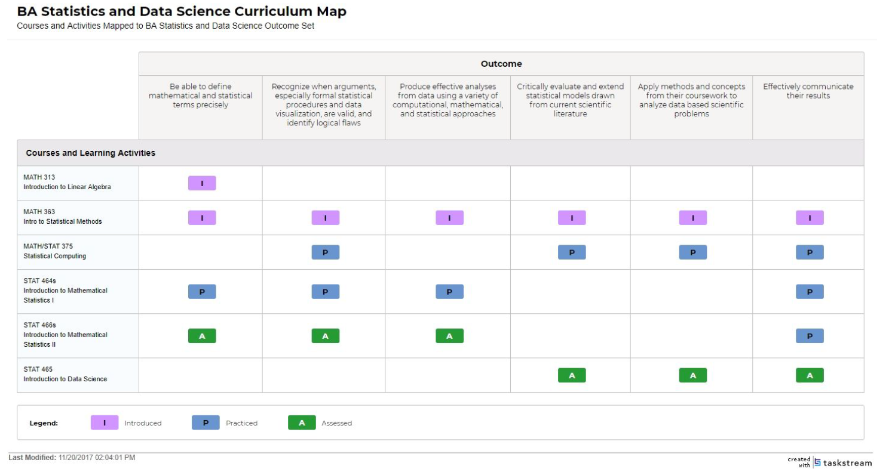

Appendix B. Assessment Plan for Student Learning

