NEW ACADEMIC PROGRAM-GRADUATE MAJOR
ADDITIONAL INFORMATION FORM

- MAJOR DESCRIPTION -provide a marketing/promotional description for the proposed program. Include the purpose, nature, and highlights of the curriculum, faculty expertise, emphases (sub-plans; if any), etc. The description should match departmental and college websites, Graduate Catalog and Program Descriptions page, handouts, promotional materials, etc.

- NEED FOR THE MAJOR/JUSTIFICATION-describe how the major fulfills the needs of the city, state, region, and nation. Provide market analysis data or other tangible evidence of the need for and interest in the proposed major (and emphases, if applicable). This might include results from surveys of current students, alumni, and/or employers or reference to student enrollments in similar programs in the state or region. Include an assessment of the employment opportunities for graduates of the program for the next three years. Curricular Affairs can provide a job posting/demand report by skills obtained/outcomes/CIP code of the proposed major. Please contact Martin Marquez to request the report for your proposal.

- MAJOR REQUIREMENTS– complete the table below by listing the major requirements, including required number of units, required core, electives, and any special requirements, including emphases (sub-plans), thesis, internships, etc. Note: information in this section must be consistent throughout the proposal documents (comparison charts, sample plan of study, curricular/assessment map, etc.). Delete the EXAMPLE column before submitting/uploading. Complete appropriate table found in Appendix A if requesting a corresponding master’s degree (for PhD proposals) and/or minor.
Total units required to complete the degree |  | EXAMPLE  60
Pre-admissions expectations (i.e. academic training to be completed prior to admission) |  | Earned bachelor’s degree; training in field; statement of purpose
Major requirements. List all major requirements including core and electives. If applicable, list the emphasis requirements for each proposed emphasis*. Courses listed must include course prefix, number, units, and title. Mark new coursework (New). Include any limits/restrictions needed (house number limit, etc.). Provide email(s)/letter(s) of support from home department head(s) for courses not owned by your department. |  | Complete 12 units of core coursework:  -ECOL 547 (3) Introduction to Theoretical Ecology  -ARE 631 (3) Arts-based Research  -MAS 587 (3) Chicana Gender Perspectives  -DNC 500 (3) Dance and Culture  Complete 18 units of electives from the following list. At least 3 units must be internship or practicum. Limit of 9 units of independent study may be used towards this requirement.:  Complete 12 units of theory and method coursework from the following list:  Complete 18 units of dissertation :
Research methods, data analysis, and methodology requirements (Yes/No). If yes, provide description. |  | Yes. Students complete 12 units of theory and method in the field.
Internship, practicum, applied course requirements (Yes/No). If yes, provide description. |  | Yes. Students complete 3 units of an internship or practicum in the field.
Master thesis or dissertation required (Yes/No). If yes, provide description. |  | Yes. Students complete 18 units of dissertation.
Additional requirements (provide description) |  | Written and oral comprehensive examinations  Oral dissertation defense
Minor options (as relevant) |  | No required minor options. Open options.
*Emphases are officially recognized sub-specializations within the discipline. Proposed official emphases having similar curriculum with other plans (within department, college, or university) may require completion of an additional comparison chart. Complete the table found in Appendix B to indicate if emphases should be printed on student transcripts and diplomas.

- CURRENT COURSES– using the table below, list all existing courses included in the proposed major. You can find information to complete the table using the UA course catalog or UAnalytics (Catalog and Schedule Dashboard> “Printable Course Descriptions by Department” On Demand Report; right side of screen). If the courses listed belong to a department that is not a signed party to this implementation request, upload the department head’s permission to include the courses in the proposed program and information regarding accessibility to and frequency of offerings for the course(s). Upload letters of support/emails from department heads to the “Letter(s) of Support” field on the UAccess workflow form. Add rows to the table, as needed.
Course prefix and number (include cross-listings) | Units | Title | Course Description | Pre-requisites | Modes of delivery (online, in-person, hybrid) | Typically Offered  (F,W, Sp, Su) | Dept signed party to proposal? (Yes/No)

- NEW COURSES NEEDED – using the table below, list any new courses that must be created for the proposed program. If the specific course number is undetermined, please provide level (ie CHEM 6**). Add rows as needed. Is a new prefix needed? If so, provide the subject description so Curricular Affairs can generate proposed prefix options.
Course prefix and number (include cross-listings) | Units | Title | Course Description | Pre-requisites | Modes of delivery (online, in-person, hybrid) | Status* | Anticipated first term offered | Typically Offered  (F, W, Sp, Su) | Dept signed party to proposal? (Yes/No) | Faculty members available to teach the courses
*In development (D); submitted for approval (S); approved (A)

Subject description for new prefix (if requested). Include your requested prefix, if any:

- FACULTY INFORMATION- complete the table below. If UA Vitae link is not provided/available, attach a short CV (2-3 pages) to the end of the proposal or upload to the workflow form (in the “Letter(s) of Support” field). UA Vitae profiles can be found in the UA directory/phonebook. Add rows as needed. Delete the EXAMPLE rows before submitting/uploading. NOTE: full proposals are distributed campus-wide, posted on committee agendas and should be considered “publicly visible”. Contact Martin Marquez if you have concerns about CV information being “publicly visible”.
Faculty Member | Involvement | UA Vitae link or “CV attached”
EX: Joan Smith | Teach FIRE 588 | CV attached
EX: Mike Smith | Teach FIRE 687, Faculty advisor, Internship supervisor | UA Vitae Link

- SAMPLE PLAN OF STUDY- provide a sample plan of study.

- STUDENT LEARNING OUTCOMES AND CURRICULUM MAP—describe what students should know, understand, and/or be able to do at the conclusion of this major. Work with Office of Instruction and Assessment to create a curricular map using Taskstream. Include your curricular map in this section (refer to Appendix C for sample Curriculum Map generated using Taskstream).

EMPHASIS LEARNING OUTCOMES – at minimum, provide two unique learning outcomes for each proposed emphasis. Which courses will Introduce, Practice, and/or Assess the learning outcomes? Use the table below to provide the information. Add rows as needed. Delete this section and table if the proposed major does not include emphases.
Emphasis | Learning Outcome | Introduced | Practiced | Assessed
EX: Fire Management | Students will be able to…. | FIRE 578 | FIRE 581 | FIRE 687

Curriculum Map:

- ASSESSMENT PLAN FOR STUDENT LEARNING- using the table below, provide a schedule for program assessment of intended student learning outcomes 1) while students are in the program and 2) after completion of the degree. Add rows as needed. Delete EXAMPLE row.

Learning Outcomes | Sources(s) of Evidence | Assessment Measures | Data Collection Points
EXAMPLE: Outcome 1: Discern ethical problems, ambiguities, controversies, and assumptions in … | Course-embedded assessments  Pre-post student reflection essays; exit surveys; student focus group; alumni surveys | Exams, papers, and other forms of student work  Summative critical self-reflections | End of each course  End of CHEM 6** course

- PROGRAM ASSESSMENT PLAN- using the table below, provide a schedule for program evaluation 1) while students are in the program and 2) after completion of the degree. Add rows as needed. Delete EXAMPLE rows.

Assessment Measure | Source(s) of Evidence | Data Collection Point(s)
EXAMPLE: Job Placement Statistics | Student/Alumni Survey | At graduation and as part of alumni survey
EXAMPLE: Academic Program Review | Reviewers’ responses | Year 5 and every 7 years afterwards

- ANTICIPATED STUDENT ENROLLMENT- complete the table below. What concrete evidence/data was used to arrive at the numbers?
5-YEAR PROJECTED ANNUAL ENROLLMENT
 | 1st Year | 2nd Year | 3rd Year | 4th Year | 5th Year
Number of Students

Data/evidence used to determine projected enrollment numbers:

- ANTICIPATED DEGREES AWARDED- complete the table below, beginning with the first year in which degrees will be awarded. How did you arrive at these numbers? Take into consideration departmental retention rates. Use National Center for Education Statistics College Navigator to find program completion information of peer institutions offering a same or similar program.
PROJECTED DEGREES AWARDED ANNUALLY
 | 1st Year | 2nd Year | 3rd Year | 4th Year | 5th Year
Number of Degrees

Data/evidence used to determine number of anticipated degrees awarded annually:

- PROGRAM DEVELOPMENT TIMELINE- describe plans and timelines for 1)marketing the program and 2)student recruitment activities.

- DIVERSITY AND INCLUSION-describe how you will recruit diverse students and faculty to this program. In addition, describe retention efforts in place or being developed in order to retain students.

- ABOR REQUIREMENT: New Academic Program Request. This section is required by ABOR. Most of the information can be copied/pasted from completed sections above. Instructions/clarification for completing the table below, from ABOR, can be viewed/downloaded here.
University: University of Arizona

Name of Proposed Academic Program:

Academic Department:

Geographic Site:

Instructional Modality:

Total Credit Hours:

Proposed Inception Term:

Brief Program Description:

Learning Outcomes and Assessment Plan:

Projected Enrollment for the First Three Years:

Evidence of Market Demand:

Similar Programs Offered at Arizona Public Universities:

New Resources Required? (i.e. faculty and administrative positions; infrastructure, etc.):

Program Fee/Differentiated Tuition Required? YES NO Estimated Amount:

Program Fee Justification:

Specialized Accreditation? YES NO

Accreditor:

Appendix A. Master’s and/or Minor Requirements. Complete Table 1 if requesting a corresponding master-level program. Complete Table 2 if requesting a corresponding minor. Delete EXAMPLE column before submitting.

Table 1: Corresponding Master Program
Degree type |  | EXAMPLE  Master of Science
Available for direct admission (Yes/No)? If yes, provide pre-admission expectations. |  | Yes, earned bachelor’s degree; training in field; statement of purpose
Total units required to complete degree |  | 30
Major requirements. List all major requirements including core and electives. If applicable, list the emphasis requirements for each proposed emphasis*. Courses listed must include course prefix, number, units, and title. Mark new coursework (New). Include any limits/restrictions needed (house number limit, etc.). Provide email(s)/letter(s) of support from home department head(s) for courses not owned by your department. |  | Complete 12 units of core coursework:  -ECOL 547 (3) Introduction to Theoretical Ecology  -ARE 631 (3) Arts-based Research  -MAS 587 (3) Chicana Gender Perspectives  -DNC 500 (3) Dance and Culture  Complete 3 units of methodology from the following list:  Complete 9 units of electives from the following list. At least 3 units must be internship or practicum. Limit of 3 units of independent study may be used towards this requirement.:  Complete 6 units of master thesis:
Research methods, data analysis, and methodology requirements. (Yes/No). If yes, provide description. |  | Yes, complete 3 units of methodology coursework.
Internship, practicum, applied course requirements (Yes/No). If yes, provide description. |  | Yes, complete at least 3 units of internship at an organization in the field of study.
Master thesis required (Yes/No). If yes, provide description. |  | Yes, complete 6 units of master thesis.
Additional requirements (provide description) |  | Written comprehensive examination. Oral defense of master thesis.
Minor options (as relevant) |  | Minor not required. Open options.
* Emphases are officially recognized sub-specializations within the discipline. Proposed official emphases having similar curriculum with other plans (within department, college, or university) may require completion of an additional comparison chart. Complete the table found in Appendix B to indicate if emphases should be printed on student transcripts and diplomas.

Table 2: Corresponding Minor
Minimum total units required |  | 9
Total transfer units that may apply to minor |  | 3
Pre-admissions expectations (i.e. academic training to be completed prior to admission) |  | Discuss minor choice with major professor and include in plan of study.
Minor requirements. List all minor requirements including core and electives. Courses listed must include course prefix, number, units, and title. Mark new coursework (New). Include any limits/restrictions needed (house number limit, etc.). Provide email(s)/letter(s) of support from home department head(s) for courses not owned by your department. |  | Complete 6 units of core coursework from the following options:  -ECOL 547 (3) Introduction to Theoretical Ecology  -ARE 631 (3) Arts-based Research  -MAS 587 (3) Chicana Gender Perspectives  -DNC 500 (3) Dance and Culture  Complete 3 units of internship:
Research methods, data analysis, and methodology requirements (Yes/No). If yes, provide description. |  | Yes, research methods and data analysis course covers methods in the field including…
Internship, practicum, applied course requirements (Yes/No). If yes, provide description. |  | Yes. Complete 3 units of internship with an organization in the field.
Additional requirements (provide description) |  | Comprehensive exam.

Appendix B. Emphasis Print Information-if applicable, complete the table below to indicate if proposed emphases should be printed on transcript and diploma. Add rows as needed. Note: emphases are displayed on transcript and diplomas as “ _______ Emphasis”. Delete EXAMPLE row before submitting.

Emphasis | Print on transcript | Print on diploma
EX: Fire Safety | Yes | Yes

Appendix C. Sample Curriculum Map for BA in Statistics and Data Science. Created using taskstream. Contact OIA for assistance in creating your curriculum map.
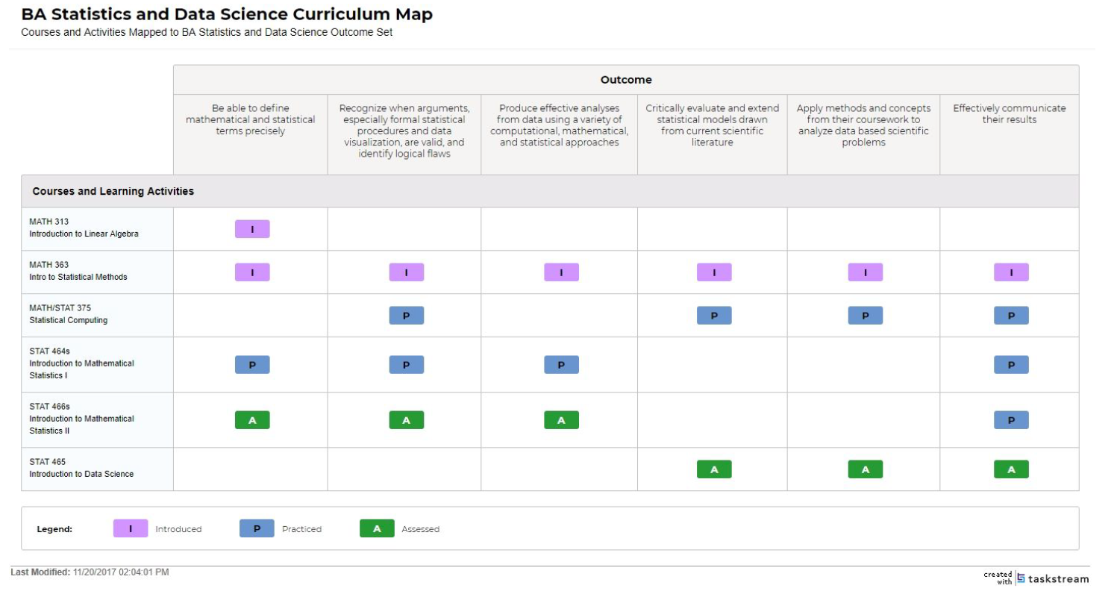

Appendix B. Assessment Plan for Student Learning

