Degree Search Updates Guide

Office: | Curricular Affairs
Business Process Name: | Degree Search Updates
Creation Date: | August 1, 2017
Updated: | August 15, 2019
Updates for Catalog Year: | 2020-2021
Modified by: | Martin Marquez II

Table of Contents

- Completing the Degree Search Spreadsheet 2

- Degree Search Update Contact Information 4

- Submitting Degree Search Updates 5

- Completing the Degree Search Spreadsheet

Degree Search updates must be submitted using the “Degree Search Spreadsheet”. Download the spreadsheet and fill in the yellow highlighted columns. Contact your assigned Degree Search Update Contacts (refer to page 5) if you would like to be sent degree search spreadsheets from last year’s submission.
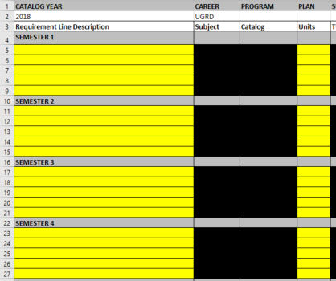

****Degree Search 4-year plan requirements must match ADVIP requirements****

Under “Requirement Line Description” column:
List the catalog subject, course number and official title for specific required coursework (e.g. ASTR 250 Fundamentals of Astronomy). Add a generic title/place holder for requirements with more than one course option (e.g. Upper Division Major Elective, General Elective, Minor Course, First Semester Chemistry, etc.). These generic line titles must match your advisement reports. Use the same terminology (Math, Second Language, GE Tier 1, GE Tier 2) when listing generic GE/Foundations coursework.
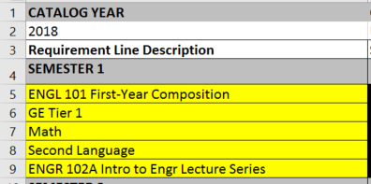

Under “Units” column:
List the minimum unit amount for the corresponding line (do not list unit ranges). For example, Foundation Math line could contain 3 and 4 unit courses; list 3 units.

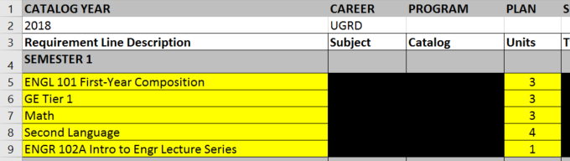

You can modify the spreadsheet to add additional rows, if needed, under the appropriate semester.

- Submitting Degree Search Updates Spreadsheet

- Save the spreadsheet using the plan (and sub-plan) code and catalog year in the title (Examples: w/out sub-plan: COMMBA.2020 and w/sub-plan:MATHBS.ECONBUS.2020)

- Upload the spreadsheet to your UA Curriculum Update module (ADVIP update module in UAccess) under “Curriculum Update Extras” tab during the submission window. Degree search spreadsheets are due as part of the annual ADVIP updates on or before October 25, 2019.

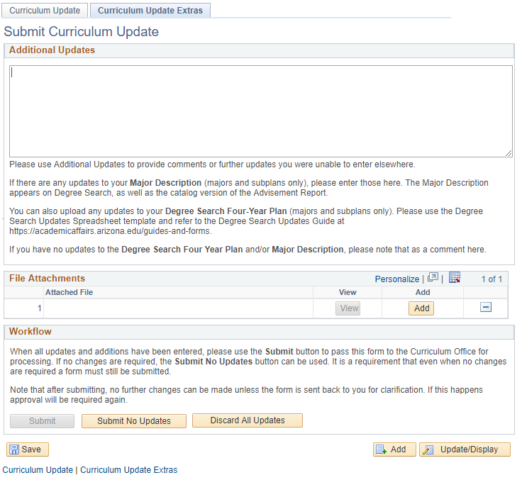
Click “Add” to upload your Degree Search in the “Curriculum Update Extras” tab.

- Degree Search Update Contacts

College | Curricular Affairs Contact | AA Business Analyst Contact
College of Agriculture and Life Sciences | Stephanie Carlson | Heather Jepsen
College of Architecture Planning, & Landscape Architecture | Stephanie Carlson
College of Education | Stephanie Carlson
College of Engineering | Liz Sandoval
College of Fine Arts | Stephanie Carlson
College of Humanities | Stephanie Carlson
College of Letters, Arts, and Science | Stephanie Carlson
College of Medicine | Stephanie Carlson
College of Nursing | Stephanie Carlson
College of Pharmacy | Liz Sandoval
College of Science | Liz Sandoval
College of Social and Behavioral Sciences | Stephanie Carlson
Eller College of Management | Stephanie Carlson
Honors College | Stephanie Carlson
Mel and Enid Zuckerman College of Public Health | Stephanie Carlson
UA South | Liz Sandoval

Contact Information:
- Stephanie Carlson scarlson@email.arizona.edu
- Heather Jepsen jepsenh@email.arizona.edu
- Liz Sandoval esandmar@email.arizona.edu

