Updated By: | Curricular Affairs
Last updated: | 01/27/21

Business Process Summary
Submitting a Course Modify Form through UAccess will result in the modification of an existing active course. Only the primary academic organization may submit the form. Please note that if content is changing more than 25% then an inactivation and new course add will be needed to update the course.

Business Process Procedures:

Step A | Submitting a Course Modify Form
Please use the Course Catalog to review the current structure of the course before submitting a modification. If you are requesting a cross-list be added please contact the department and coordinate the number being used as a catalog number may only be used once.
UAccess Administrative Login> Curriculum Management>Course Catalog>Course Catalog

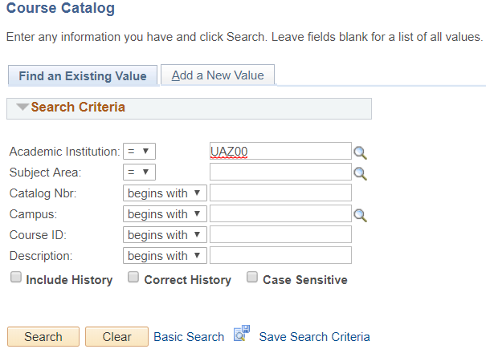

Navigate to the Course Catalog Modify Forms in UAccess.
UAccess Administrative login> Navigator Bar> Curriculum Management> UA Curriculum Management>Course Management> UA Course Modify

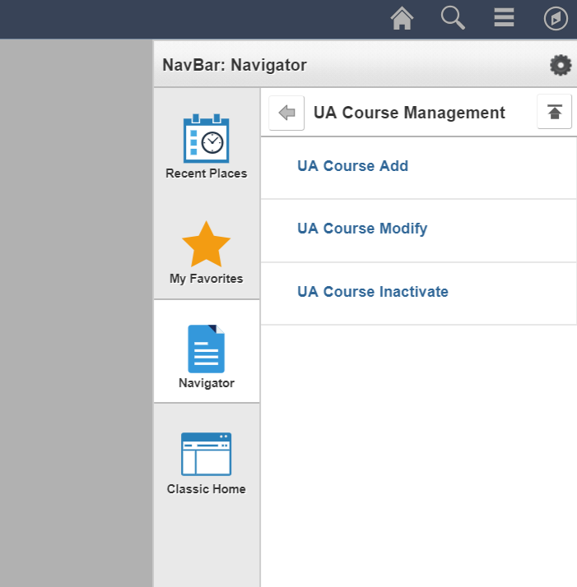

Please note: department representative must request access via the “UAccess Access Provisioning Tool” before this point.

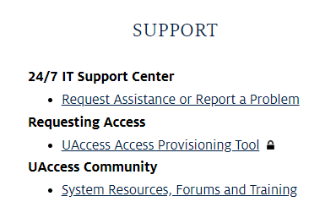
Click “Add a New Value” to start a new Course Modify Form. Please have the Course ID ready.

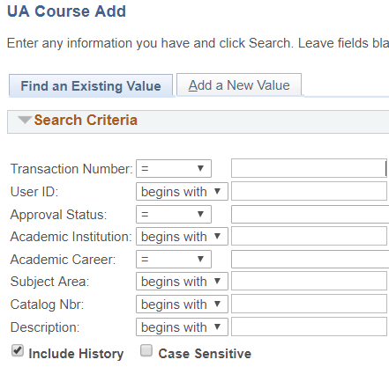

Enter the Course ID, and the fields from the course catalog will pull into the form for the displayed fields.
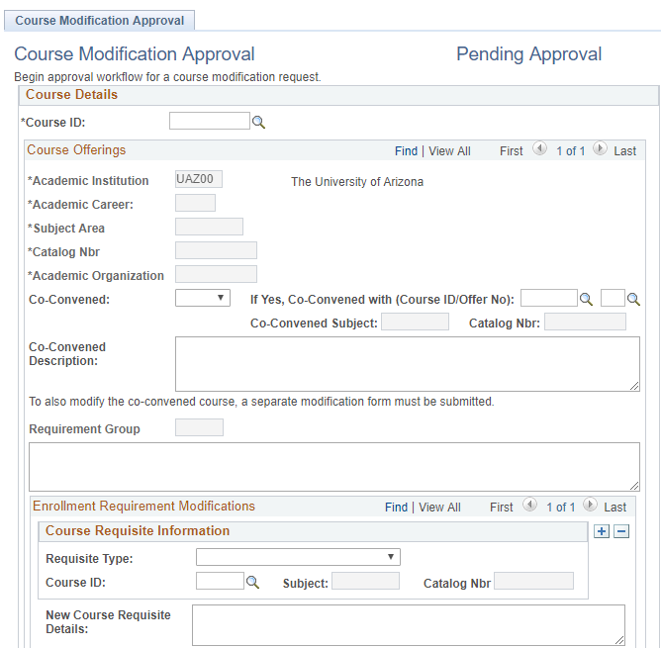

Proceed to the Typically Offered field and select the semesters that the course is usually taught in, corresponding to each campus (MAIN, UA ONLINE, Distance, South, Phoenix, and Community). The Typically Offered field is for with Degree Map but does not restrict the course to these semesters.

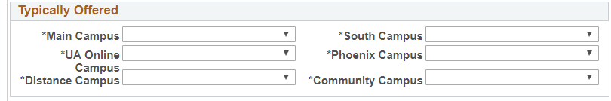

If the course has a 400 or 500 catalog number and wants to have the option to be Co-Convened between undergraduate and graduate careers, the ending numbers must match and are Co-Convened on the Course Catalog here.

Co-Convened courses are two separate courses (with the same two ending numbers) with separate course ID’s, one being 400 while other is 500.

Under the drop down next to “Co-Convened”, if Yes is selected, the Co-Convened course must be inputted under “Co-Convened With” (whether it is with an existing course or from another 400/500 course being added). The 500 level course must preserve the graduate experience and the form must explain the Graduate level requirements.

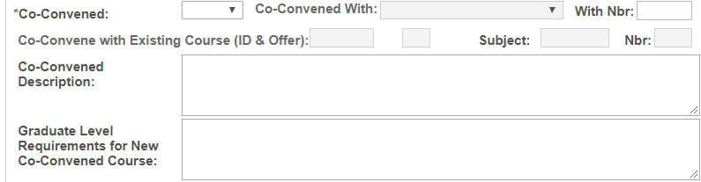

If the course being added/modified is neither a 400 or 500 level, or if the course is no longer to be Co-Convened these fields may be left blank.

Enrollment Requirements

Course Requisite Information:
Requisite Types can either be Co-Requisite or Pre-Requisite.

If a Course Requisite is selected, the Course ID of the corresponding Co or Pre-Requisite must be filled in here. If multiple, click the plus sign to add more than one Requisite.

Any pre-requisite listed here that needs to be enforced MUST also have New Requirement Group information listed in Step 7.

(pre-requisites that are only filled in this field are not enforced and are text only).

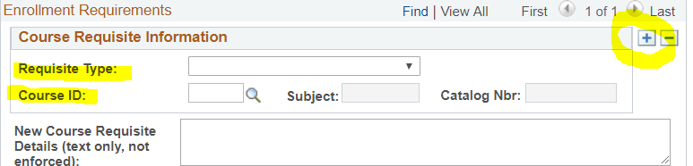
Existing Requirement Groups to be added:
If there is already an existing Requirement Group that is needed for the course being created, this is where that can be inputted. In addition, if you are needing an existing requirement group on top of new additional enrollment restrictions, please fill out here and in New Requirement Groups to be Added. If not sure, requirement groups can be checked in UAccess.
Administrative login>Curriculum Management>Enrollment Requirements>Enrollment Requirement Groups

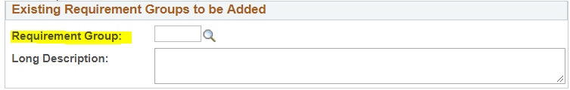

New Requirement Groups to be Added:
Any Enrollment Requirements that want to be enforced need to be listed here as well as in step 5.
Requirement Groups are enrollment filters that are enforced for the course.

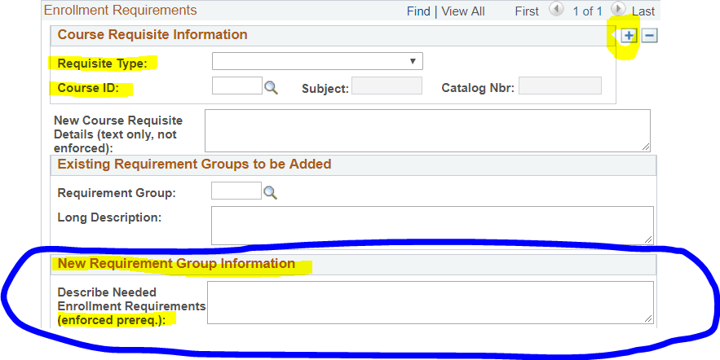

A Course Syllabus is needed if modification includes change in units, course component, and/or learning outcomes.

Click “Add File” to insert a Syllabus.

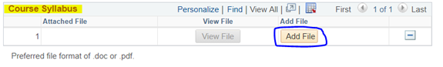

Course Attributes

If there are Course Attributes associated to the course, each Course Attribute also has a Course Attribute Value needing to be added.

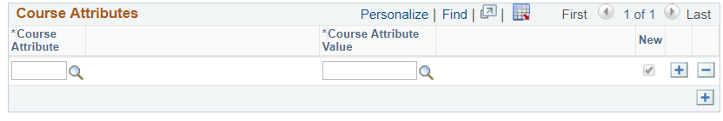

Here is a list of Course Attrbutes departments can utlize. For more information see BPG on Course Attributes.

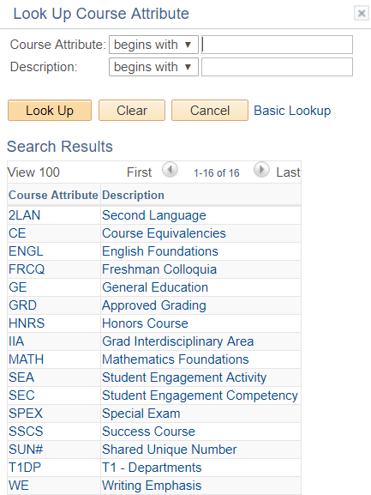

Please be sure that for CE-CL or GE attributes that when the extra tab appears that they are filled out completely before submitting.

Course Modification – Complete:
- First Effective Term (Please check the deadlines, as modifications approved or submitted past Go Live for a term requested will be moved to the next available term)
- List any changes to enrollment requirements- If changes or additions to the Course Requisites (department enforced requisites), Enrollment Requirement Group, or adding an existing requirement group, please specify change and needed logic here
- Indicate changes to catalog entry below- List any changes desired to be made to the course catalog, description update, unit change, grading basis change, course attributes, field trip text, etc… Please remember to check the Course Catalog before submitting to be sure that the change being indicated is not already in place
- Briefly describe why this change is necessary- Provide the justification for the update needed.
- What other courses, departments or programs may be affected by these changes? (Consider such things as prerequisites, cross listed courses, degree requirements, related changes being made elsewhere, etc.)- This field is to assist departments in considering the items that need to be updated along with the requested change. Please be sure to submit modification forms for all Course IDs that are involved in the change.
  - If you are changing the description on a 400/500 level co-convened course please submit modification forms for both the 400 and 500.
  - This field also assists other departments reviewing the form regarding affected items.
- Course Fee- Populates from the course catalog and is not editable as a UA Course Fee Add, Modify, or Inactivation form must be submitted for a Fee change.
- Additional Information- This field is for any other information your department feels is important for the reviewers to note.

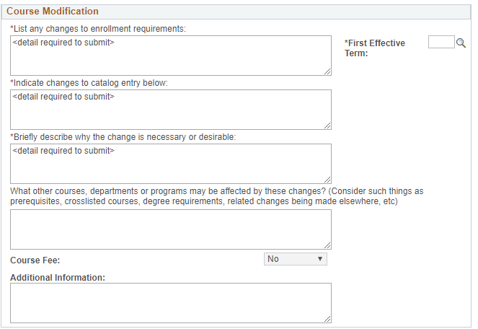
Once finished please select the Submit button at the bottom of the form to send to Curricular Affairs to start the approval route. The form may be tracked by the Transaction Number that populates at the top right corner of the form.

If questions on these, please email courseapprovals@list.arizona.edu.

Course Initiators:

You are responsible for using UA Course Management to monitor the progress of the Course Forms you have submitted and will need to follow-up directly with the approvers listed on the stage the form is on for questions or concerns. Please view comments before contacting approvers.

If an approver is no longer at the UA please notify Curricular Affairs to make updates.

