Updated By: | Curricular Affairs
Last Updated: | 11/17/2023

Business Process Summary
Submitting a Course Add Form through UAccess for courses that do not currently exist in the Course Catalog.

Business Process Procedures:

Step A | Course Syllabus
Prepare a Course Syllabus in accordance with the General Catalog’s Course Syllabus Policy Pages”:

- Undergraduate
- Graduate

Co-convened 400/500-level classes- we prefer a convened syllabus for the course approval process. When a single syllabus is used, it must meet the requirements of both the Undergraduate and Graduate Syllabus Policies and must clearly distinguish between graduate and undergraduate requirements and workload expectations, however the instructor may use separate syllabi for the graduate and undergraduate offerings if desired.

When are syllabi not needed?
Syllabi are not required for 498H and for the individualized study courses (_91,_92,_93,_94, _99, 900, 908, 909, 910, 915, 920, 925).

Step B | Submitting a Course Add Form
Please use the Course Catalog to check and make sure there are no active records of the corresponding Subject and Catalog Number being added, to ensure that the desired catalog subject and numbers have not been used / had enrollment in the last 8 years. Duplication of an active course is prohibited.
UAccess Administrative Login> Curriculum Management>Course Catalog>Course Catalog

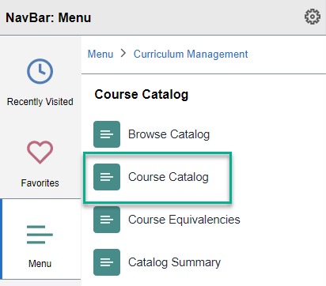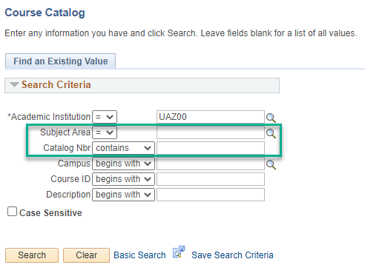

To submit a new UA Course Add request please navigate to the add forms in UAccess.

UAccess Administrative login> Navigator Bar> Curriculum Management> UA Curriculum Management>UA Course Management> UA Course Add

Please note: if you are unable to access the above, please see step 16.

Click “Add a New Value” to start a new Course Add Form. Please have the information needed to add a brand new course to the Course Catalog.

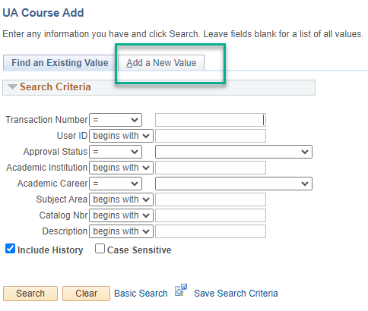

The Academic Institution will autofill to UAZ00. Make sure to check the Academic Career as the system defaults to Undergraduate. Fill out the following tabs including Academic Career (if different from UGRD), Subject Area, Catalog Nbr, and Academic Organization.

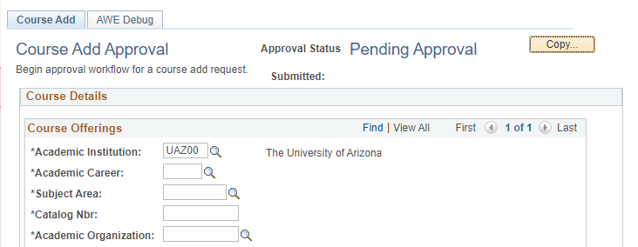

Please note that a catalog nbr may not be reused if there have been enrollments in the last 8 years.

Typically Offered

Select the semesters that the course is usually taught in from the drop-down menus of each campus (MAIN, UA ONLINE, Distance, South, Phoenix) that your program is currently offered on.

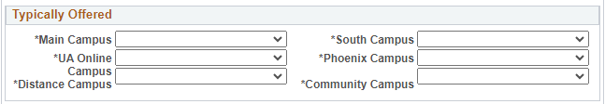

If you are not approved for or offering on a campus please select “Not Offered” frmom the drop down menu.

If the course being added is neither a 400 or 500 level, or if the courses do not wish to be Co-Convened, then select co-convene “No” the fields below in step 5 can be left blank and proceed to step 6.

If Yes, fill out the indicated fields and attached a co-convened syllabus:



Select if co-convening with an existing course or a new course.

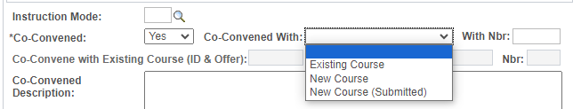

“With Nbr:” will be the transaction number for the co-convened add or modify form submitted to go with the new co-convene.

If value selected is existing course, add the Course ID for the existing course, list Offer # “1” in the second box, and fill out the Graduate Level Requirement. The Graduate Requirement will be what the graduate students only will be doing during the course, i.e. grad only discussion, paper, presentation, etc… that differentiates the graduate student experience during the course.
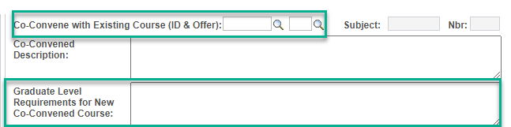

If new course selected fill out the form completely and save. Use the New Window link in the top right corner to open a new form, copy the transaction number from the saved form, and use the Copy button at the top of the newly opened form to copy the saved transaction, adjust needed fields for the graduate or undergraduate form being filled out second.


The Co-Convened designation will be located on the the UA Characteristics tab in the course catalog once the courses are approved and pushed to the catalog. The designation indicates to RCS that the sections of the listed 400/500 course may meet together. Co-convened courses should have the matching title, description, catalog number ending (i.e. 422/522), and subject (exceptions for GIDP/UGRD co-convenes, i.e. ENTO/EIS), with the co-convened component and units all matching.

Enrollment Requirements

There are two types of enrollment requirements:

- Course Requisites- NOT enforced by UAccess for student enrollment. Fill out only the following:
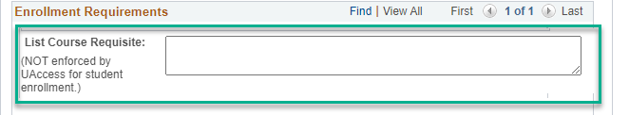
- Requirement Group: ENFORCED by UAccess for student enrollment. Must provide all logic and items that are on the student record that can be enforced by the system that the department would like such as follows:
- Courses- Fill out Course Requisite Information by section for each course needed. Select Pre or Co requisite for the course being added to the requirement group. Then fill out the Course ID. There is a search if you do not already have the needed course ids. Select the + button and repeat for all courses being included in the requirement group.
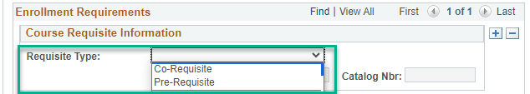
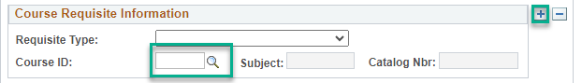
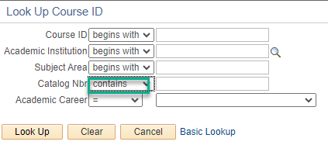
Be sure that Catalog Nbr’s search parameter is contains or no results will pull. This lookup will not include inactive or new courses. You will need to add a comment to the form if inactive or new courses will be used in the requirement group. Please include the course id for the inactive courses, which can be located in the course catalog, and the transaction number for the new add form submitted for the new courses being used. The comment section is located at the bottom of the form. Select the + button to add a new comment. Be sure to save.
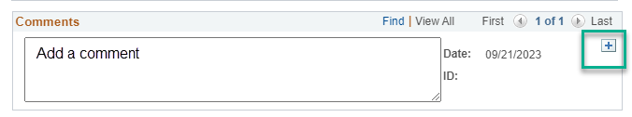
- Academic level, plan code, program code, academic standing, sub plan code, cumulative grade point average, student group, test score.

If you are not sure what you would like for a requirement group please reach out to Academic Catalog and Policy (Registrar’s Office)ACP, catalog@arizona.edu for a consultation with their team as they program the requested requirements once approved and can assist with any detailed questions on requirement groups for catalog or section level.

Once all courses are listed and the logic needed is known, fill out the New Requirement Group Information section with the student display and the logic if they differ.
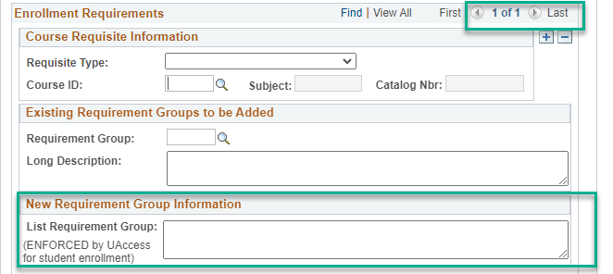

If an existing Requirement Group is being used no other sections need to be filled out in the enrollment requirements section. Please provide the existing requirement group number in the box indicated below or use the lookup to located the needed requirement group.
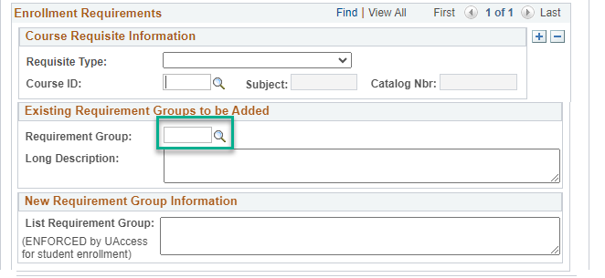

Provide Short Course Title, Long Course Title, and Course Description. Indicate the First Term Effective and select Course Type permanent or temporary.
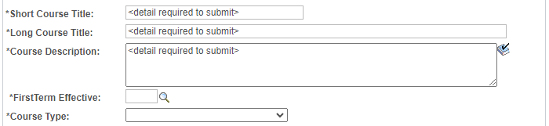
A finalized course syllabus must be attached to the Course Add Form. Be sure that the information being provided in the form matches the information being provided in the syllabus. Check that the syllabus meets all criteria outlined in the General Catalog Syllabus Policy sections:

- Undergraduate
- Graduate
- Co-convened must meet all requirements outlined in the graduate and undergraduate syllabus sections listed above.

To add the syllabus click “Add File”.
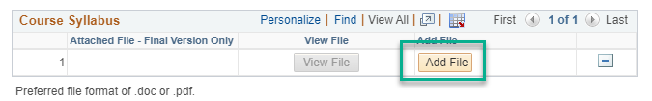

Select Choose File to locate and select the needed file. Once file is selected, click Upload.
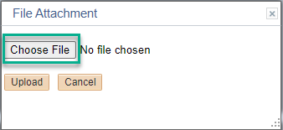

** Be sure to save the form before submitting so the form reviewer is able to open the file. If submit is selected without save, the file can be corrupted and the reviewer may have to return your form to attach the file.
UA Courses must have a minimum of 3 Learning Outcomes not only on the syllabus but pasted into the Add Form here. Learning Outcomes are not the same as Course Objectives. Learning Outcomes describe what the student will be able to do upon completion of the course, Course Objectives describe what the student will do during the course. 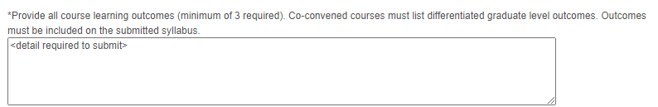
Co-convened(400/500 level courses):
Learning outcomes for co-convened courses must have a minimum of 1 graduate specific learning outcome listed in the Learning Outcome text box just above.
GENED Courses:
When the GEED and GEAT attributes are selected the General Education tab will appear and the learning outcomes tied to GENED will populate in the above field.
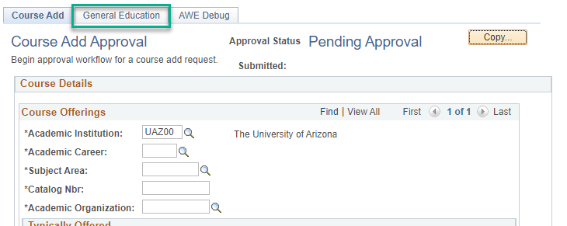

If you have 3 learning outcomes and no additional learning outcomes no further learning outcome steps are needed.

If you only have two GENED learning outcomes, you will need to go to the Propose Additional SLOs section on the General Education tab and add at least 1 additional learning outcome to meet the 3 minimum. If you have 3 GENED learning outcomes and additional learning outcomes, please add the additional learning outcomes to the General Education tab. Once this is complete all learning outcomes will appear in the field listed above.
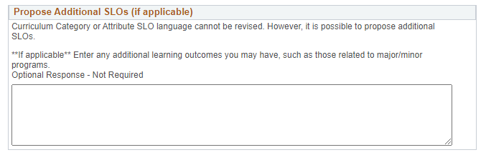
Course Attributes

If there are Course Attributes associated to the course, each Course Attribute also has a Course Attribute Value that needs to be added.

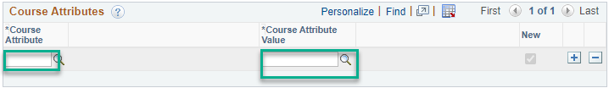

- SEC or SEA- if either are selected the other must be added. Engagements must have both competency and an activity attribute.
- GEED or GEAT- Minimum must have one GEED and one GEAT attribute. These are General Education attributes, and the General Education tab will appear at the top of the form when selected, if the course is newly transitioning to GENED, has not been reviewed in 5 or more years, or you are changing something on the General Education tab the tab must be filled out. If your course was recently reviewed and you are not changing the specific fields on the GENED tab, please list “NA” in all fields marked required fields on the tab that are not being altered.
For full details on the General Education tab completion please visit GE Course Proposals | General Education Refresh (arizona.edu)
- CE-CL- Must select the plus button on the offering section of the form and add the new subject for the secondary offering. If there is an issue with existing catalog numbers please notate the needed subject, new catalog nbr, and attribute in the summarize section.
- CE-EQ- Must provide the courses with 70% content overlap with the course being modified and summarize why the equivalency group is needed in the summarize change section.
- CE-ME- Must have an anti-requisite in the new or modification to requirement group section of the form and the course ids for the other course(s) involved and requisite type must be listed in the course id section of the Enrollment Requirements portion of the form. List the explanation of how the courses are mutually exclusive in the summarize section of the form.
- SSCS-SCS- Fill out the success course tab. For questions reach out to the General Education office.
- GEFN- Foundation courses must be discussed with the CA director before submission. Please email Curricular Affairs at curricular_affairs@list.arizona.edu before submitting a modify to add the GEFN attribute to a new or existing course.
- WE-WEC- Must show that 60% of the course grade must be based on written work. See the General Catalog for policy requirement, https://catalog.arizona.edu/policy/writing-emphasis-course.

If Course Equivalency or Mutually Exclusive are selected from the above fill out the following:


Be sure for CE-ME to fill out the above and include the anti-requisite in the Enrollment Requirements section for New Enrollment Requirement Group and submit modify forms for the course being used in the anti-requisites to add the CE-ME attribute and anti-requisites to them as well.

If attributes selected are not CE-EQ or CE-ME please leave this section blank. Please use the comment section at the bottom of the form for information not related to the noted attributes.
Additional Course Information: Fill out the fields indicated as they are required for all courses.

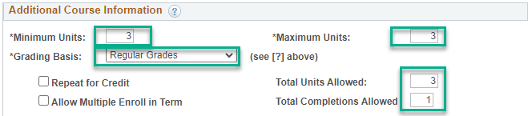

Repeating a Course: Taking the same course to attempt to improve one’s grade. The content is the same and no additional credit is given. See General Catalog-Repeating a Course for full details on repeating a course and the limitations.

Repeat for Credit: Courses taken more than once for additional credit. The course content must change each time taken. i.e. special topic house numbered colloquium, seminar, workshop, and individual study courses. Outside the house numbers fixed multiple topic courses, i.e. CRL 101, and studios may be repeat for credit.

The learning outcomes should be the same each time the course is offered but may include some additional learning outcomes that are topic specific for special topic courses.
Allow Multiple Enroll in Term: allows students to take more than one section of a repeat for credit course in the same semester. Graduate College does not allow multiple enroll in term to be selected for 909, 910, and 920 courses.

Funding Analysis: Fill out the fields indicated, if applicable to your course.

- Are you replacing a course?
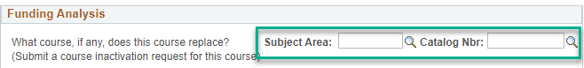
If the new Course Add is not associated with a recent course inactivation, these fields may be left blank. If the new course add is intended to replace a recent inactivation, fill out the corresponding fields with both the Subject Area and Catalog Number for the Course that is being inactivated.

- New Hire “yes” and new hire “no”, if “no” new hire and no course deletion


If the course is associated with a new hire, the highlighted field can be marked “yes”. If the course is not associated with a new hire, the highlighted field should be marked “No” as well as an explanation for how course workload will be adjusted among current staff. If the Course add is replacing a recent inactivation, please note as such.

- Programmatic need
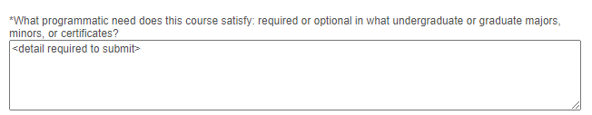
Specify whether this course is an elective or program requirement and specify the program(s) the course will be used under. If the elective is open to campus that can be indicated instead of a specific program.

- Field Trip

Specify any field trips that will occur throughout the duration of the course. If there are no field trips, this field should be left blank.

Once the form is complete, please save or ALT+1.

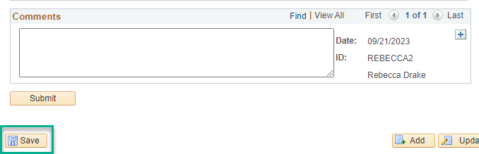

Please note: If you pasted text such as a description or learning outcomes from a source document with varying punctuation markings please save and use the transaction nbr to go out of and then re-enter the form. This adjusts to source format to the form format. You can then edit any formatting changes. These typically show as ‘¿’. Once the formatting issues are corrected, please select save and then submit.

If you are waiting for responses from your instructor or department forms can be saved and using the transaction number returned to later for update and submission.

IMPORTANT: Please only select “submit” once the form, companion form(s), and attached documents are finalized. Forms that need clarification, are missing items required, or contain typos will be returned to the initiator for updates and will need to be resubmitted. Please note the resubmit date is considered the date of submission for deadline consideration, so please be sure forms are submitted well before the final date for priority route start. See Curricular Affair’s Dates and Deadlines for full details.
 | If questions on these, please email courseapprovals@arizona.edu.
Tracking UA Course Add Forms: Course Initiators (requestor):

You are responsible for using UA Course Management to monitor the progress of the Course Forms you have submitted and will need to follow-up if there are questions or concerns. Please view all comments before contacting approvers. Please check Dates and Deadlines on the Curricular Affairs website to be sure forms complete their route by the final approval deadlines.

Form Approval Steps
Every step has different approvers and some only appear if certain criteria are met. Here are the steps:
- Curricular Preview
- Department
- Xlist Department (cross-list or pre-req course are listed)
- College
- Xlist College (cross-list or pre-req course are listed)
- Grad (if career is GRAD)
- Hnrs (HNRS attribute is included)
- Gened (SSCS or GEED/GEAT/GEFN attribute are included)
- Curricular Affairs Approval
- RCS Approval(ACP processing stage for add forms, name change was placed on hold)

To check your course add forms currently routing search you can use UA Manage Course Forms “My Other Forms”, or use UA Course Add and search by your NetID and the Approval Status “In-Process”. If the forms were not submitted by you the other search parameters may be used.

Example route: The stages marked in Green for the UA Couse Add form are the Curricular Affairs-Course Approvals approval stages. The first is the Preview stage and the last is the final approval stage.
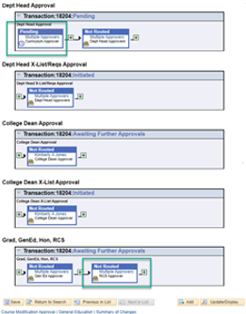

For all other stages please see the approver listed or select “multiple approvers” and the approvers provisioned for the step will appear. The UA Phonebook may be used to locate approver emails if you are unable to find them in your email directory.

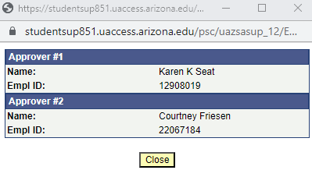

Updating Approvers Using AccessFlow

If an approver is no longer at the UA or in your department/college, please work with the appropriate business manager or administrative staff in your department/college to submit a UAccess provisioning removal and provision the new approver. Once the provisioning is completed, if there are any forms in-process(on the approval stage for the updated approver or the approval stage shows skipped) and the new approver is missing, please reach out to Curricular Affairs-Course Approvals, courseapprovals@arizona.edu, to have the new approver swapped into the approval step using our manual process.

Typically if a step says skipped, the form will be returned to the department with a comment to provision the missing department or college approver for their subject. If we have not yet gotten to the form, see the above paragraph for directions. Department initiators can preemptively avoid delays for routing by reviewing their form’s route at the bottom of the form.; The route will populate once the form is submitted. You may then request corrections to approvers listed or missing as needed. Provisioning to gain role access to any UA Course Management role is done on the UAccess Homepage, https://uaccess.arizona.edu/ .



