Name of Academic Program:

Nutrition and Food Systems (NAFS) Minor

Academic Department:
School of Nutritional Sciences and Wellness (NSW)

Geographic Site:

Main campus, in-person

Instructional Modality:

In-person

Last Term of operation:

Spring 2025

Brief Description:

The food systems minor prepares students to lead the way in finding solutions to feed a steadily increasing population while preserving precious natural resources. Experience with food systems is relevant to many different careers, including food sales and marketing, organic food certification, the nonprofit sector, food policy and lobbying, food journalism, food entrepreneurship, and more.

Reason for Disestablishing the Program:
Enrollment in the program has been decreasing over time and the minor is not sustainable. The BS in NAFS is also being disestablished warranting closure of the companion minor, as well.

Disestablishment Plan:
There are currently 8 students enrolled in the minor. These students will be notified of the plan to close the minor. Students who decide to complete the NAFS minor will have access to the courses needed, as well as advising services and the regular academic supports available to minor students in NSW.

How will program resources be reallocated? (i.e., faculty and administrative positions; infrastructure, etc.):
There is currently one FT Professor of Practice (POP) coordinating and teaching in the program. After the program is disestablished, the POP will continue to teach courses that support the BA in Food Studies, as well as food-systems related undergraduate and graduate courses in NSW. No other personnel or infrastructure reallocations will be needed.

Is this program in an ABOR designated high demand field? YES NO
Is the discontinued program in education, health, science, technology, engineering or math (STEM)?

Department Head Name: _________Ken Wilund_____________________________________
Department Head Signature: ______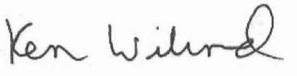_______________________

Date: ___10/18/23_____________
Dean/Assistant Dean Name: ______Michael Staten_______________________________________
Dean/Assistant Dean Signature: 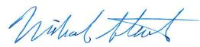__________________________________________
Date: ________10/19/23________

